
Task Management System



User Manual

Prepared by

Table of Contents
1. Version History 3
2. Reviewers 3
3. Approvers 3
4. Introduction 4
5. Definition of the System 4
6. System Functionality 4
7. Workflow and Available Actions for Employee 4
7.1 Receiving Tasks 4
7.2 Available Actions for Secretary 5
7.3 Types of Tasks in the System 9
7.4 Task States and Management 9
7.5 Support Features for Secretary 9
7.6 Tips for Efficient System Use 10
8. Mahami App 10
8.1 Login 10
8.1.1 Access the System 10
8.2 Home 12
8.3 All Tasks 16
8.3.2 Mood Indicator 18

Version History
Date | Author | Version | Change Reference
September 29, 2025 | Abdullah Shehata | V1.0 | Initial Version
October 16, 2025 | Sirine Hammad | V1.1 | Second Version

Reviewers
Name | Position | Version Approve | Date
Hussein Chamseddine | Project Manager | V1.0

Approvers
Name | Position | Version Approve | Date

Secretary Guide

Introduction
This system aims to provide a comprehensive and integrated solution for task management by facilitating and simplifying all stages related to creating, modifying, tracking, and evaluating task results. The system also focuses on enhancing workflow efficiency and ensuring tasks are executed in an organized and effective manner.
One of the primary objectives of this project is to address current challenges and problems users face in traditional systems, whether in terms of slow performance, poor coordination between teams, or difficulty accessing task-related information.
Additionally, the system seeks to improve user experience through an easy-to-use interface, providing accurate analytical reports, and smart notifications and alerts that help track work progress and ensure completion within the specified time with the ability to reassign and delegate tasks.

Definition of the System
Authorized employees can access the system through the following link:
Mahami
Note: The company email username and password are used to log into the system.

System Functionality
The system provides a set of tools for efficient task management. Here are its main functions:
- Create Tasks: You can create personal tasks or assign them to others
- Track Tasks: The system provides dedicated pages for tracking outgoing tasks or personal tasks
- Team Management: You can monitor your team's performance through a comprehensive dashboard
- Advanced Details: The system supports adding subtasks, attaching files, and adding comments
- Notifications: The system sends instant notifications about new tasks and updates

Workflow and Available Actions
This section defines the workflow and available actions for the Secretaries in the task management system, from receiving tasks from the Sector Head or Department Head to completing them

Receiving Tasks from Head of Department or Head of Sector
When a task is assigned to the Head of Department to the Department Secretary or Head of Sector to the Sector Secretary:
- The Secretary receives an instant notification of the new task
- The task appears in the "All Tasks" list with status "Not Started Yet"
- Task details can be accessed by clicking on it
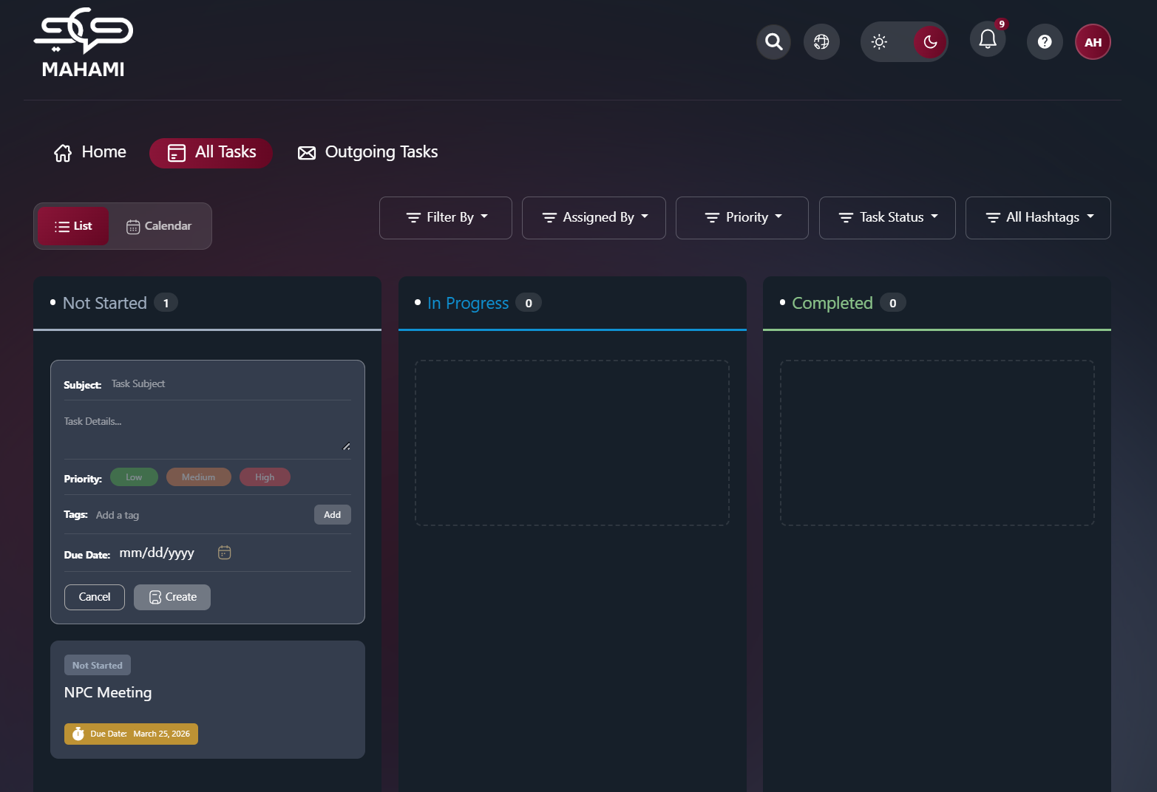

Available Actions for Secretary
- Executing the Task Personally:
Starting Work on the Task:
- Drag and drop the task into the "In Progress" column
- Task status automatically updates to "In Progress"
- Add comments and notes while working
- Upload relevant attachments and files
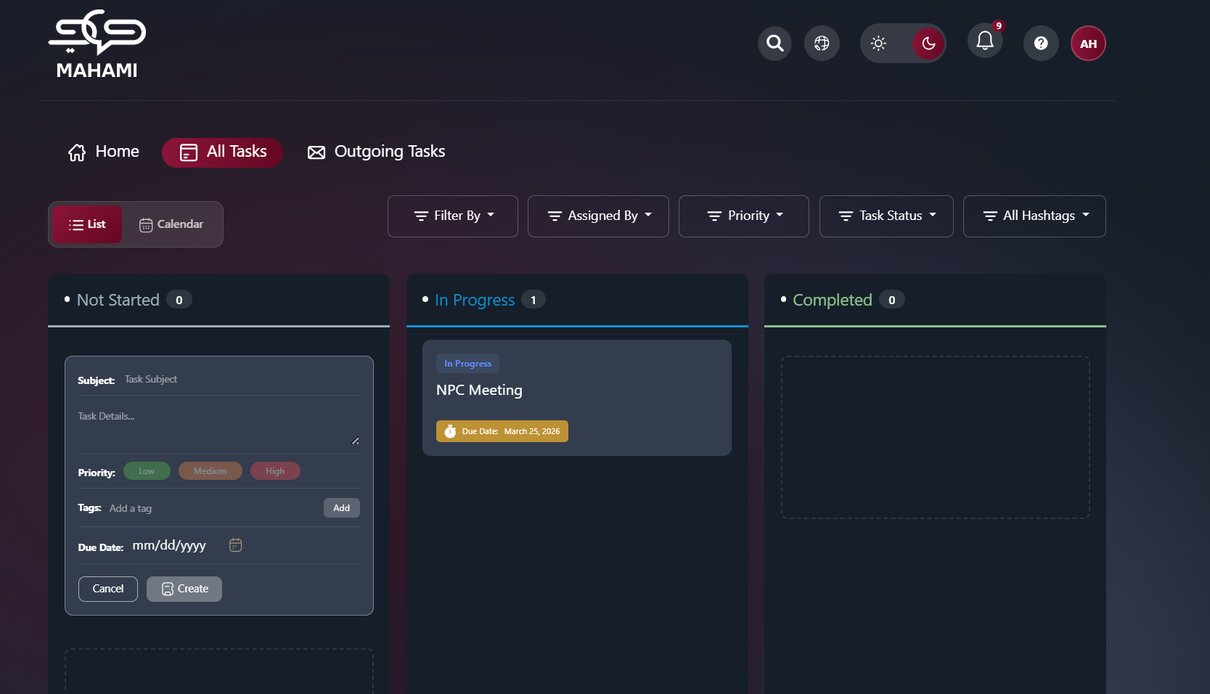
Completing the Task:
- Move the task to the "Delivered" column after completion
- Add a final report or achievement summary
- Notify the Department Head or Sector Head for review

Department Head Review or Sector Head Review: 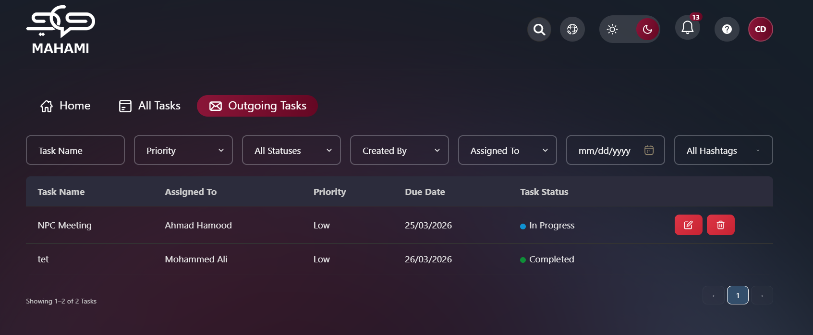
- Approval: The task becomes finally completed
- Rejection: The task returns with modification notes
- Upon approval, the completed task is evaluated
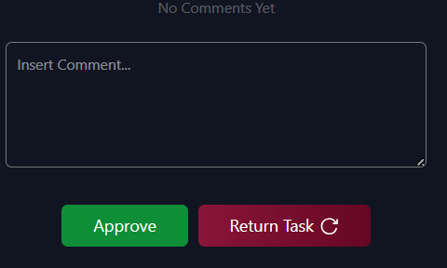
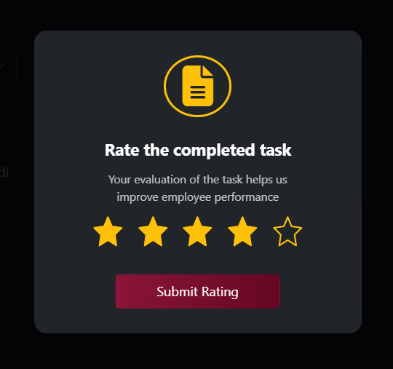

Types of Tasks in the System
- Personal Tasks:
- Self-assigned tasks
- Appear in the "All Tasks" list
- Assigned Tasks:
- Tasks sent by the Secretaries to Employees
- Tracked through the "Outgoing Tasks" section
- Subtasks:
- Parts of larger tasks
- May be linked to other main tasks

Task States and Management
Basic Task States:
- Not Started Yet:
- Newly assigned tasks
- Waiting to start execution
- In Progress:
- Tasks currently being worked on
- Continuous update of progress and notes
- Completed:
- The task has been successfully completed, formally approved, and evaluated.
- Overdue:
- Tasks that missed the deadline
- Require urgent action
- Pending Approval:
- Completed tasks awaiting review
- Requires approval from manager
- Pending Delegation Approval:
- An employee requested to delegate their task to someone else
- Approval is required from either the Head of Department or the Head of Section or Head of Sector, based on the task assigner.

Support Features for Department Secretary or Sector Secretary
- Smart Notifications:
- New task notifications
- Deadline alerts
- Delegation request status updates
- Self-Monitoring:
- Track personal work progress
- Individual completion statistics
- Completed tasks history
- Communication:
- Comments on tasks
- Request clarifications from Department Head or Sector Head
- Communicate with colleagues on shared tasks

Tips for Efficient System Use
- When Receiving a New Task:
- Read task details carefully
- Understand requirements and expectations
- Request clarification when unclear
- Estimate the time required for execution
- While Executing Tasks:
- Update task status regularly
- Add comments explaining progress
- Upload attachments progressively
- Communicate early when facing difficulties
- When Completing Tasks:
- Review the completed work
- Ensure all requirements are fulfilled
- Add a clear achievement summary
- Deliver work on time
- Mahami App

  - Login
    - Access the System
      - Accessing the System URL
Click On The Provided link: Mahami
      - Login Credentials
Use your email and password (same as Outlook credentials).
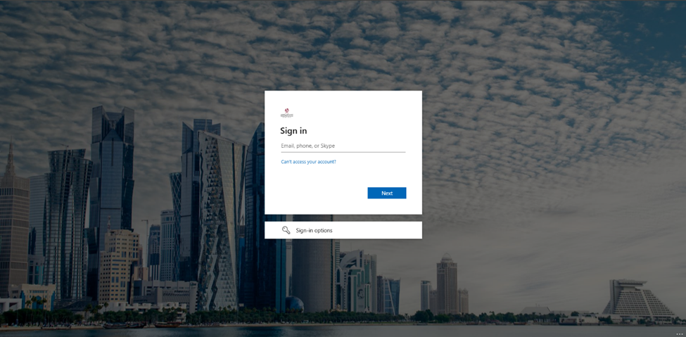

Home
After logging in, you are directed to the Home page.
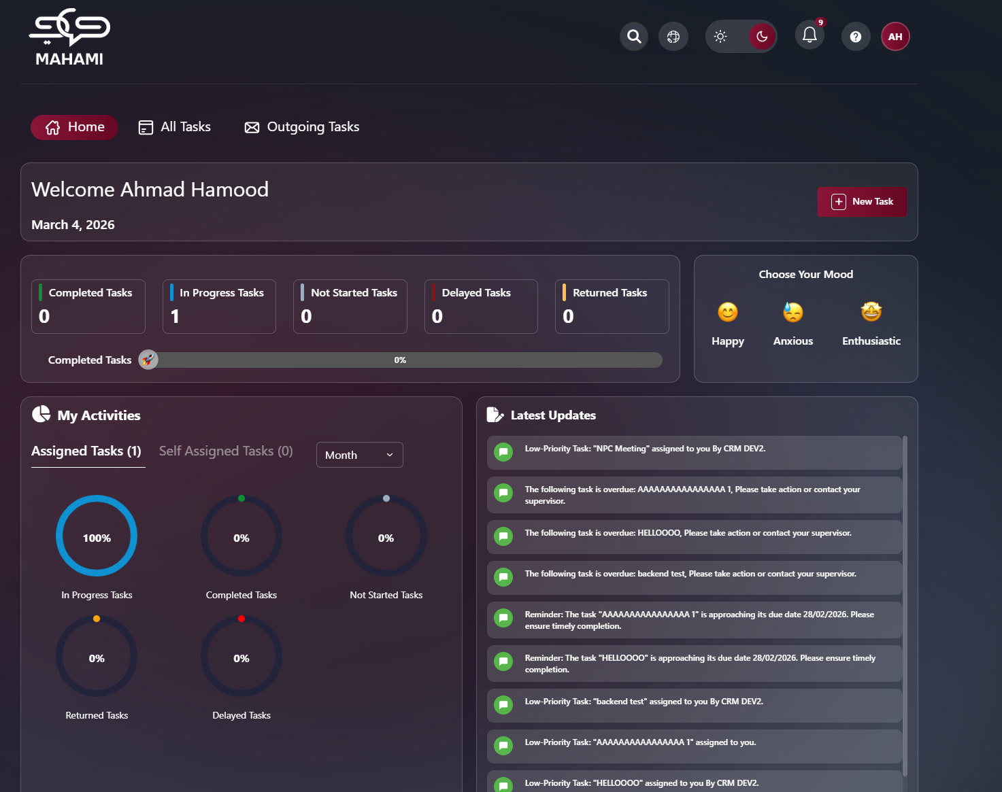

Profile Page
The profile page allows users to customize their account by uploading a personal photo, providing a personalized and comfortable user experience that suits their personal needs.
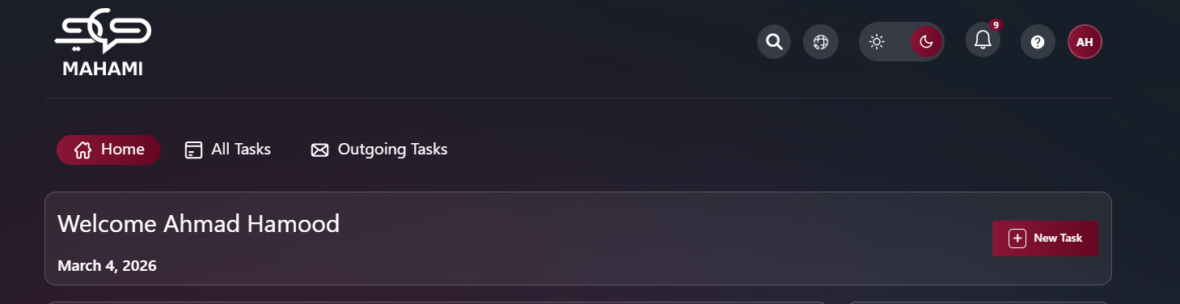
Default Avatar:
- When no photo is uploaded or after deletion, the system displays your initials
- Format: First letter of First Name + First letter of Last Name
- Unique color assigned automatically for visual distinction
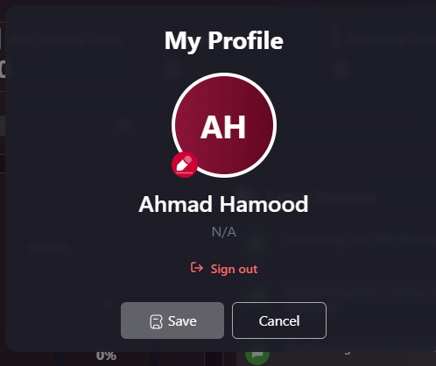
Uploading a Profile Picture:
- Click on profile icon → "My Profile"
- Click edit icon on avatar
- Select image file (JPG, PNG - Max 5MB)
- Crop if needed
- Click "Save"
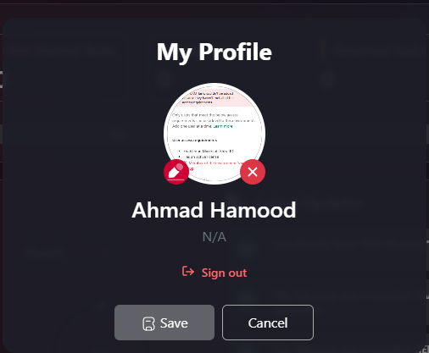
Deleting Your Profile Picture:
- Go to "My Profile"
- Hover over current picture
- Click delete icon (trash can/camera with X)
- Confirm deletion
- Click "Save"
- Profile reverts to initials avatar
Additional Profile Information:
- Full name displayed
- Department/Position (shows "N/A" if not configured)
- Sign Out button at bottom
- Save/Cancel buttons for changes
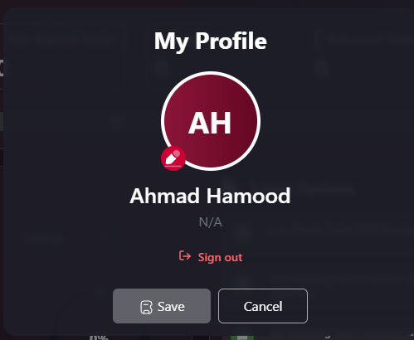

Help & Support
The Help & Support feature allows you to quickly submit questions, report issues, or request assistance directly to the support team.
Form Fields:
- Name: * Auto-filled from your profile
- Email Address: * Auto-filled with your company email
- Subject: * Brief description of your issue
- Message: * Detailed explanation of the problem
Actions:
- Send Message: Submit support request
- Cancel: Close without sending
Response Time:
- 24-48 business hours via email
Common Issues:
- Technical problems
- Feature questions
- Access issues
- Training requests
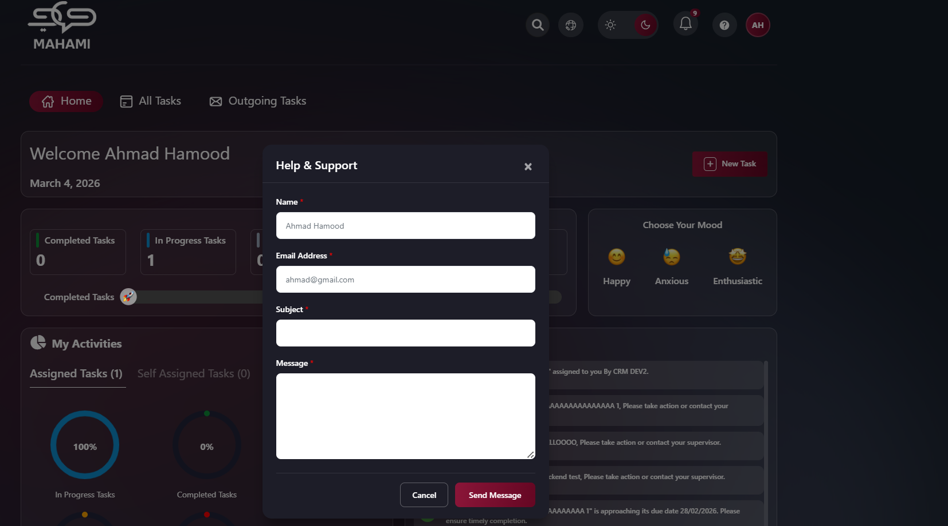

Notifications
From the top right, click on Notifications to display the notifications list.
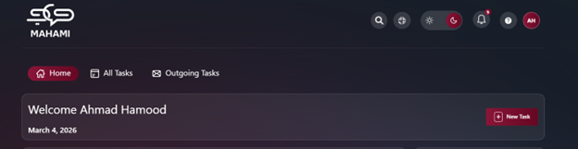
Notification Status Indicators:
- Green dot: New/unread notification
- Gray: Read notification after clicking or marking as read
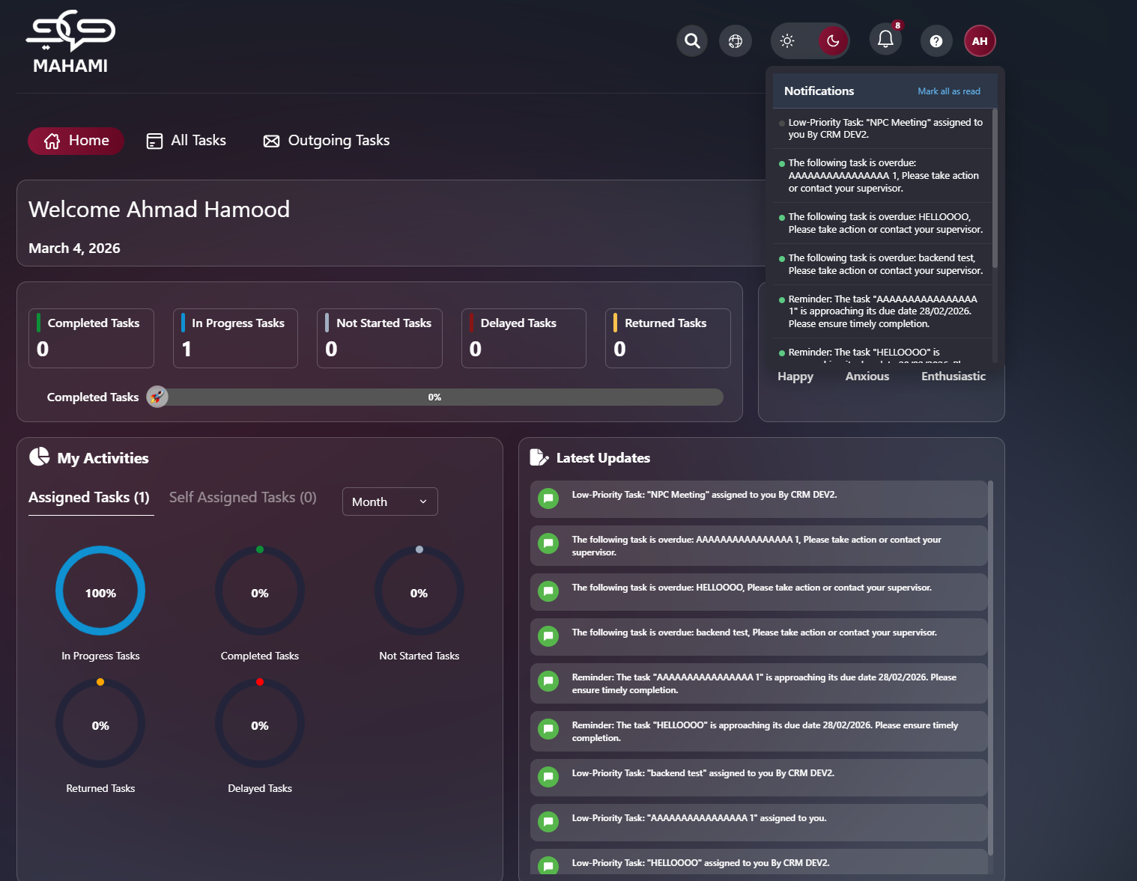
Clickable Notifications:
- Click on any notification to view the related task directly
- Automatically marks notification as read (turns gray)
- Takes you to the task details page
Managing Notifications:
- Mark All as Read: Click button at top to mark all notifications as read
- All green indicators turn gray
- Clears notification count badge
Latest Updates Section:
- Displays of recent notifications in chronological order
- Icon color based on task priority (green for low, orange for medium, red for high)
- Most recent notifications appear at the top
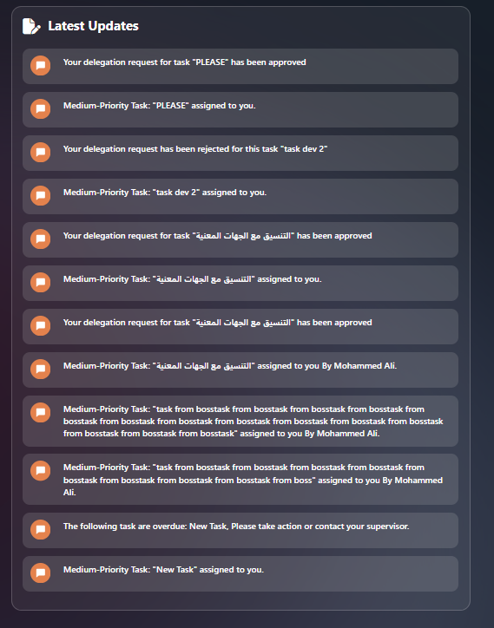
Notification Types:
- New task assigned
- Task status changed
- Deadline approaching
- Comment added
- Task completed
- Approval required
- Delegation requests

Lighting Mode
Toggle between day and night mode using the button at the top left.

Night mode
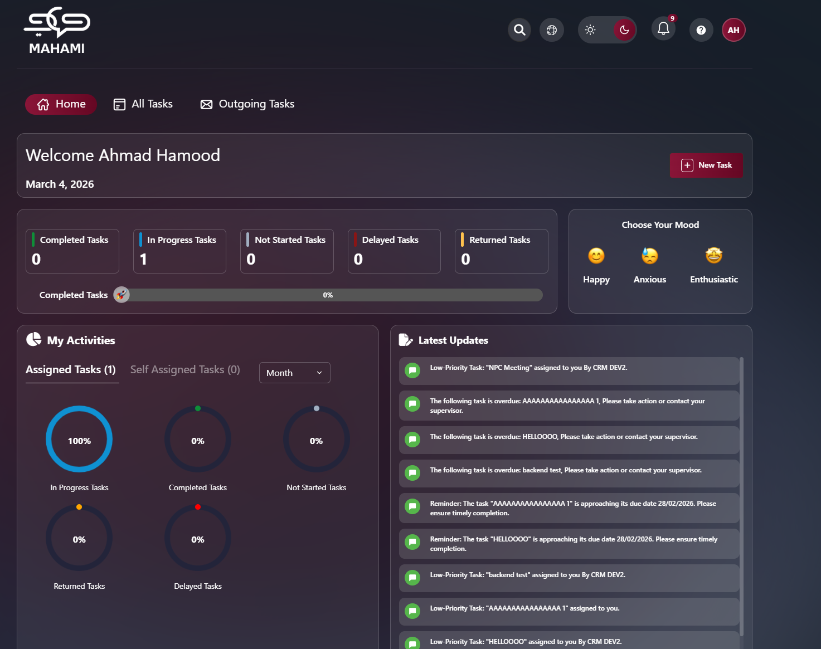

Light Mode
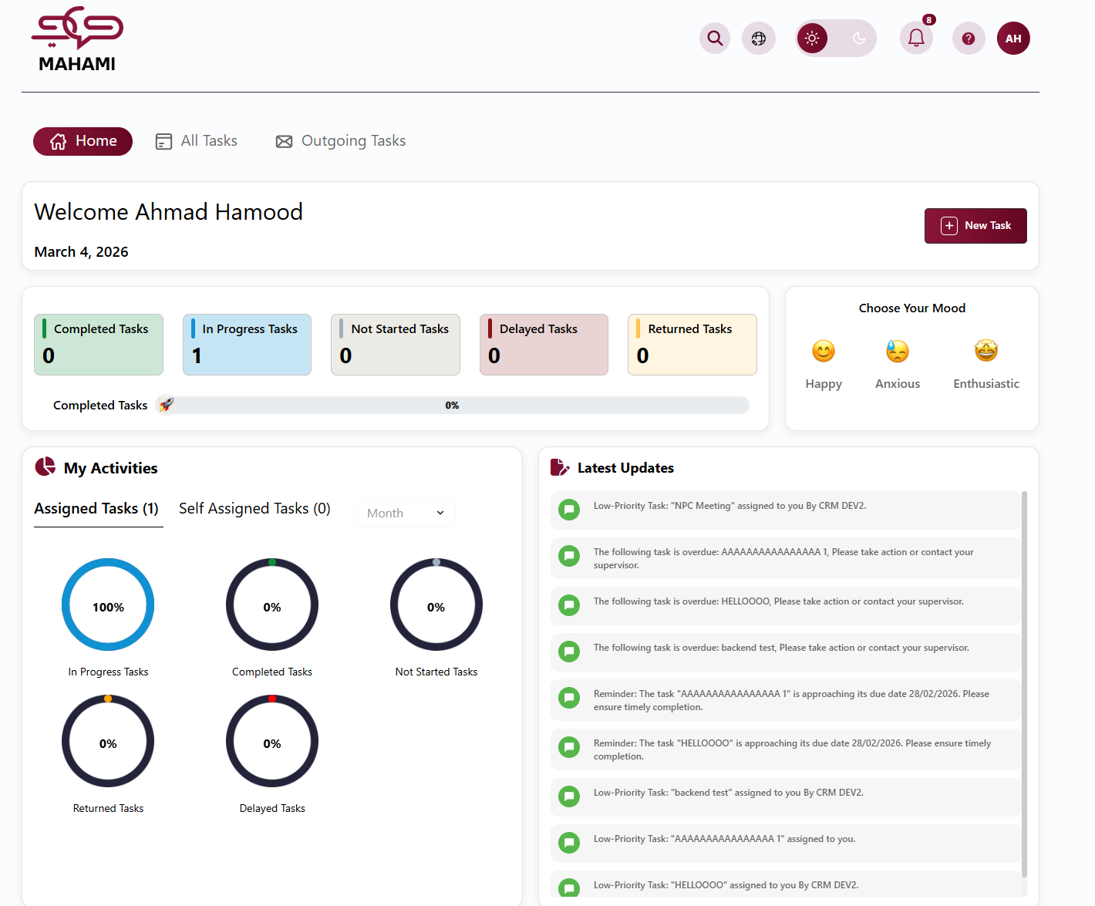

Language Selection
Choose your preferred interface language, providing a personalized and comfortable user experience that suits your personal needs.

Global Search Feature
The search function helps you quickly find any task, document, or information.
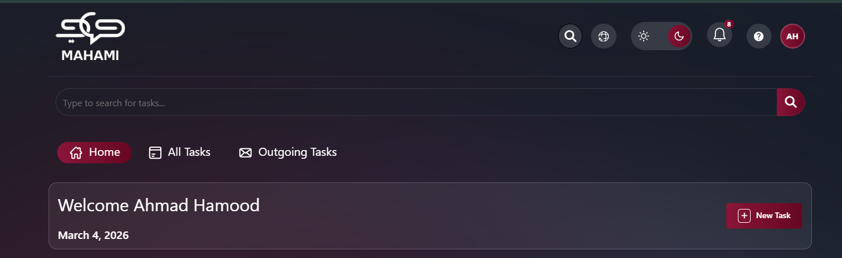

Welcome Text Message
Personalized Greeting:
- Displays at the top of the home page
- Shows personalized welcome message with your full name
- Displays current date below the greeting
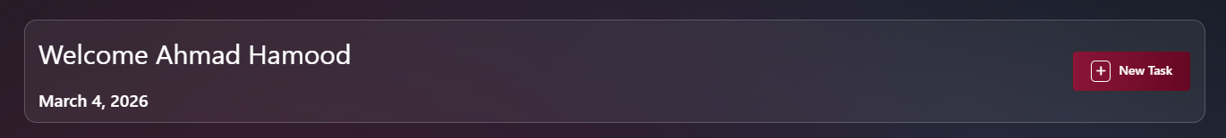

New Task
Click the "New Task" button from the top bar or from the Home page.
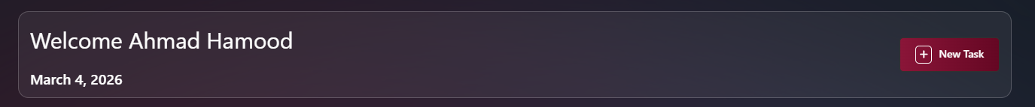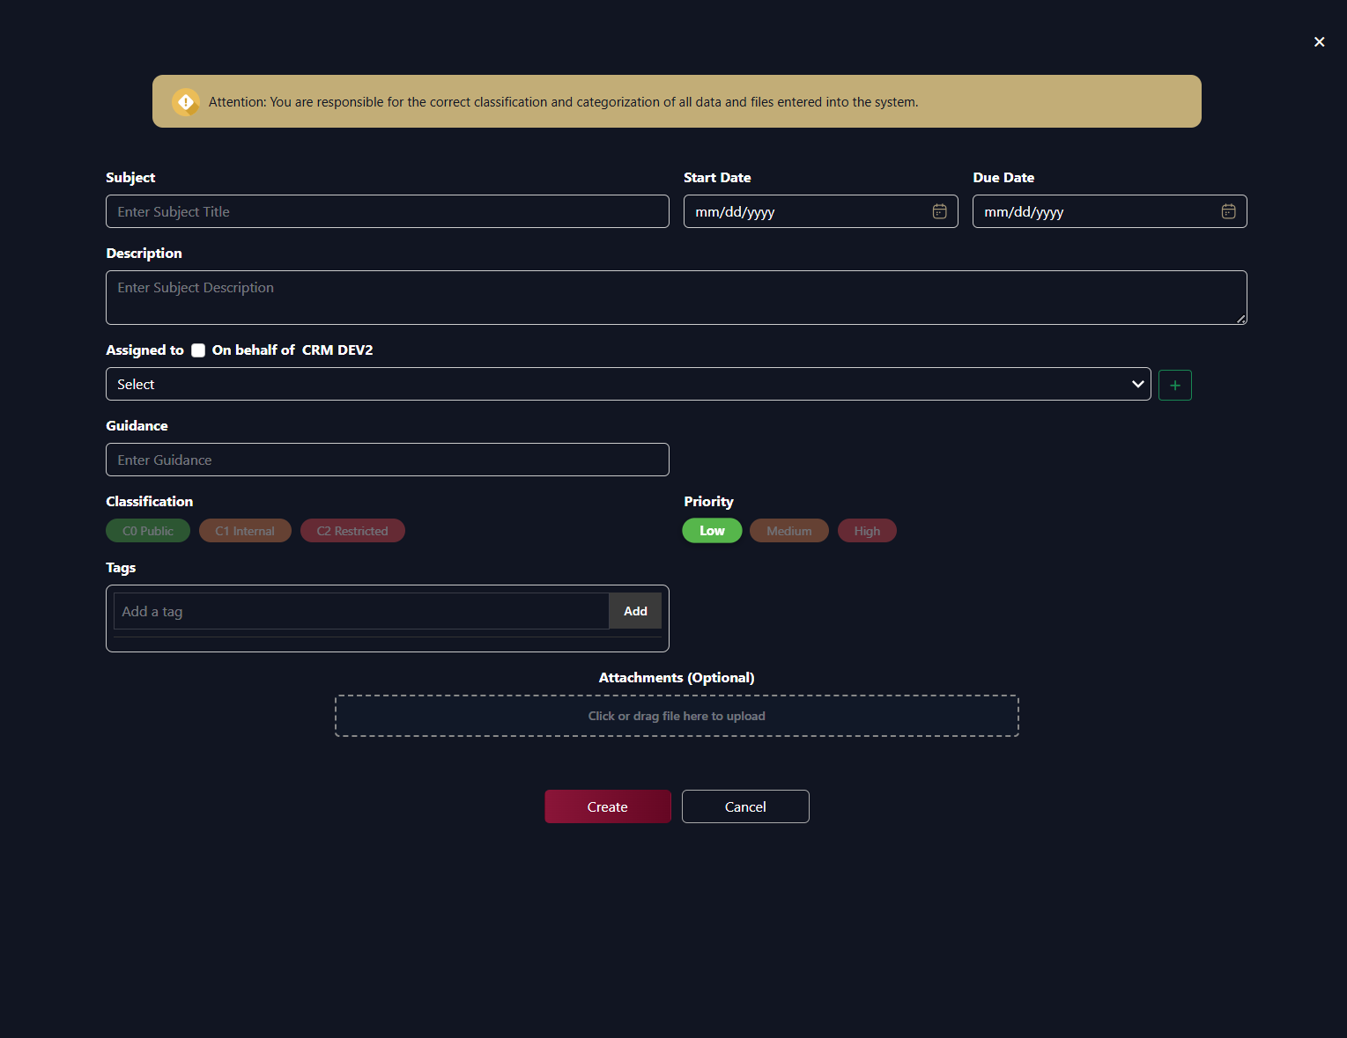Department Secretary Form
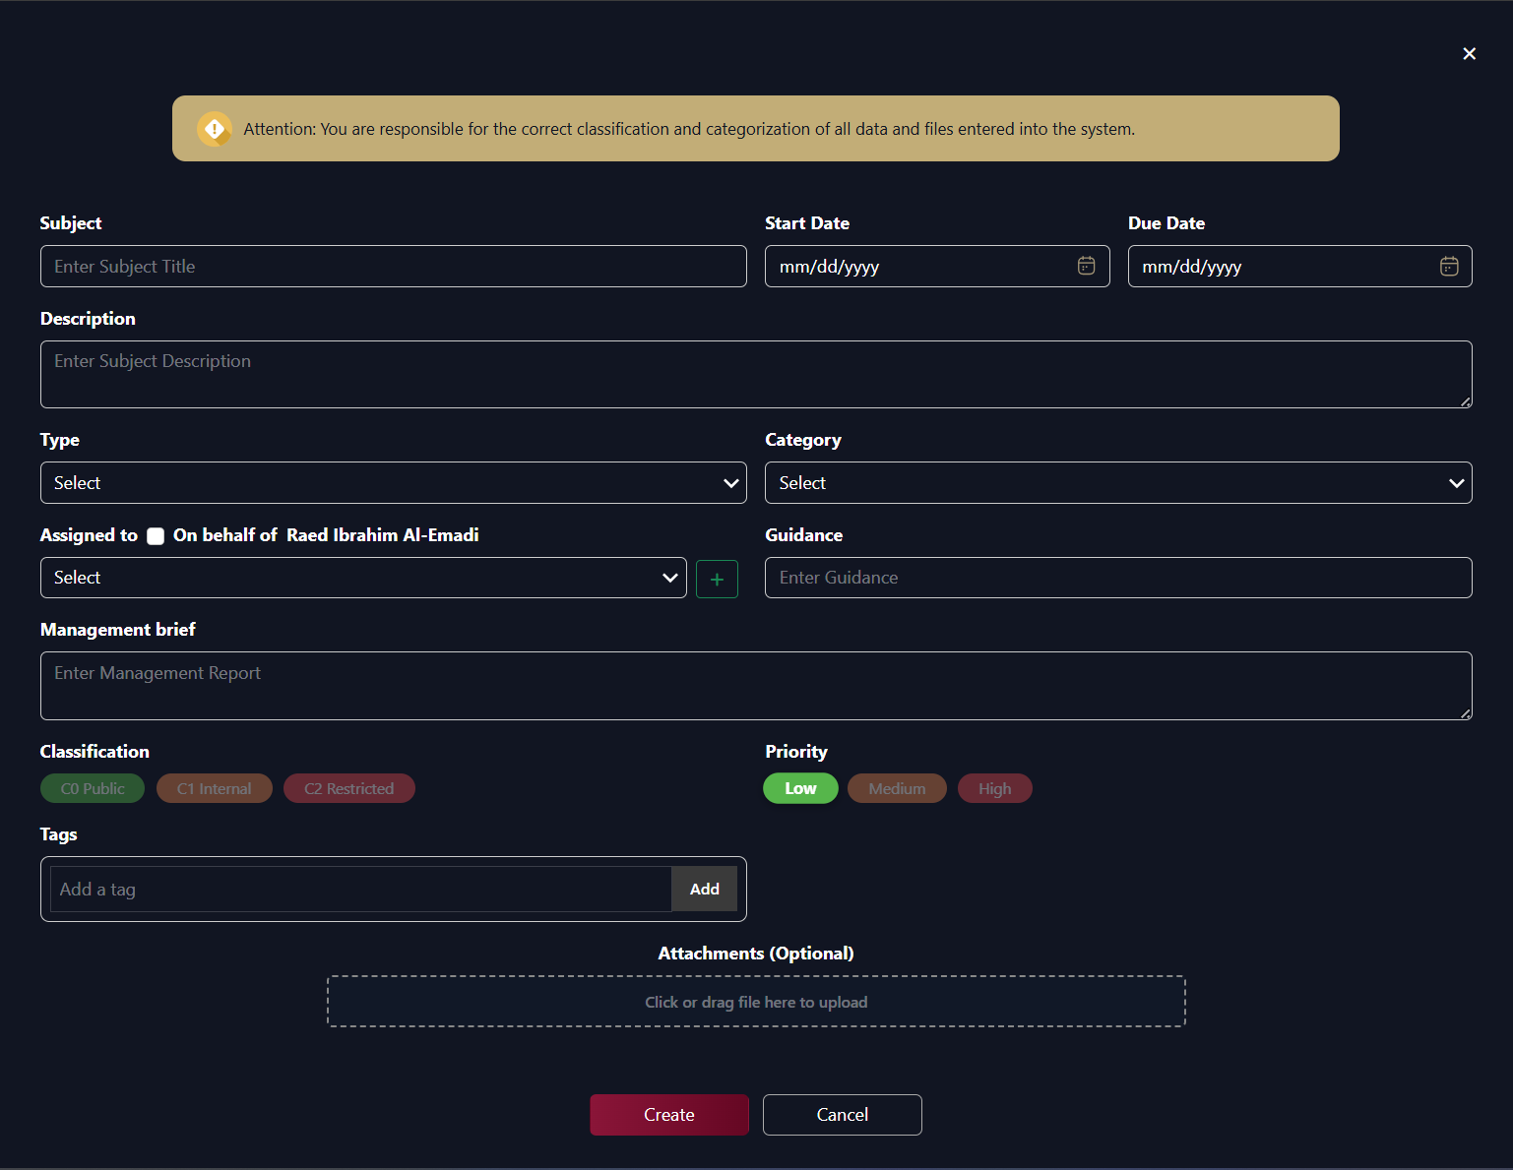
Sector Secretary Form
Data Classification Notice:
- Yellow banner at top: "Attention: You are responsible for the correct classification and categorization of all data and files entered into the system."
Fill in Task Information:
Required Fields (marked with red border when empty):
- Subject: * Task title
- Priority: * High, Medium, Low
- Due Date: * Delivery deadline
- Assigned to: * Select person(s) to execute the task
- Section: * Select section from dropdown
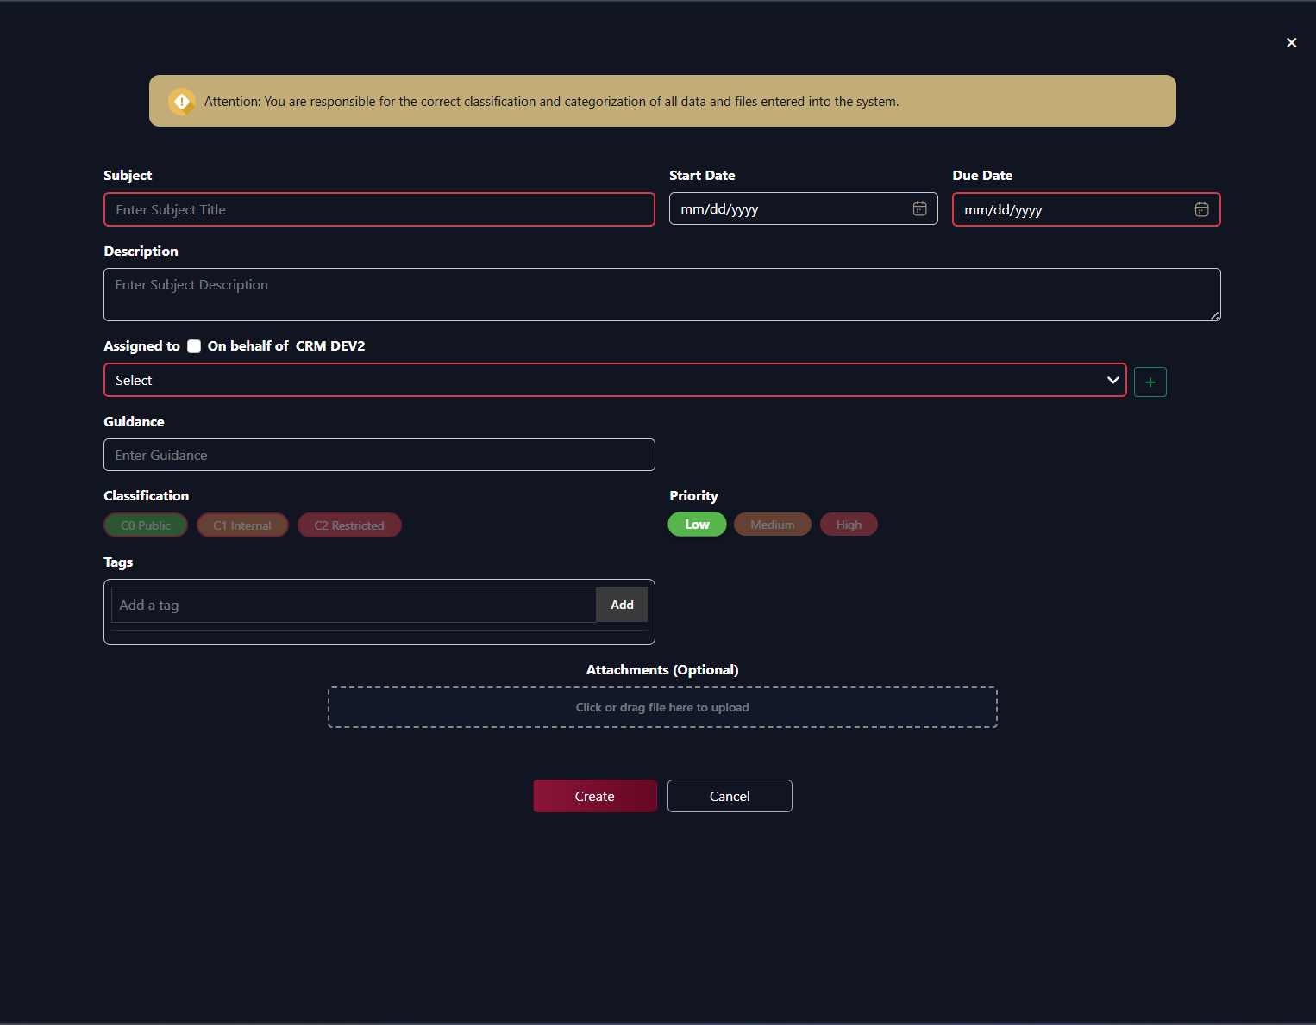
Optional Fields:
- Start Date: Planned date to start work (format: mm/dd/yyyy)
- Description: Task details and explanation
- Guidance: Add guidance and notes for the assignee
- Tags: Add classification tags for the task
Multi-Assignment Feature:
- Click the + (plus icon) in green all the way to the right to add multiple assignees
- Additional Section and Assigned to fields appear
- Select section from dropdown for each assignment
- Select assignee from the "Assigned to" dropdown
- Click trash icon to remove an assignment row
- Each assignee receives individual notification
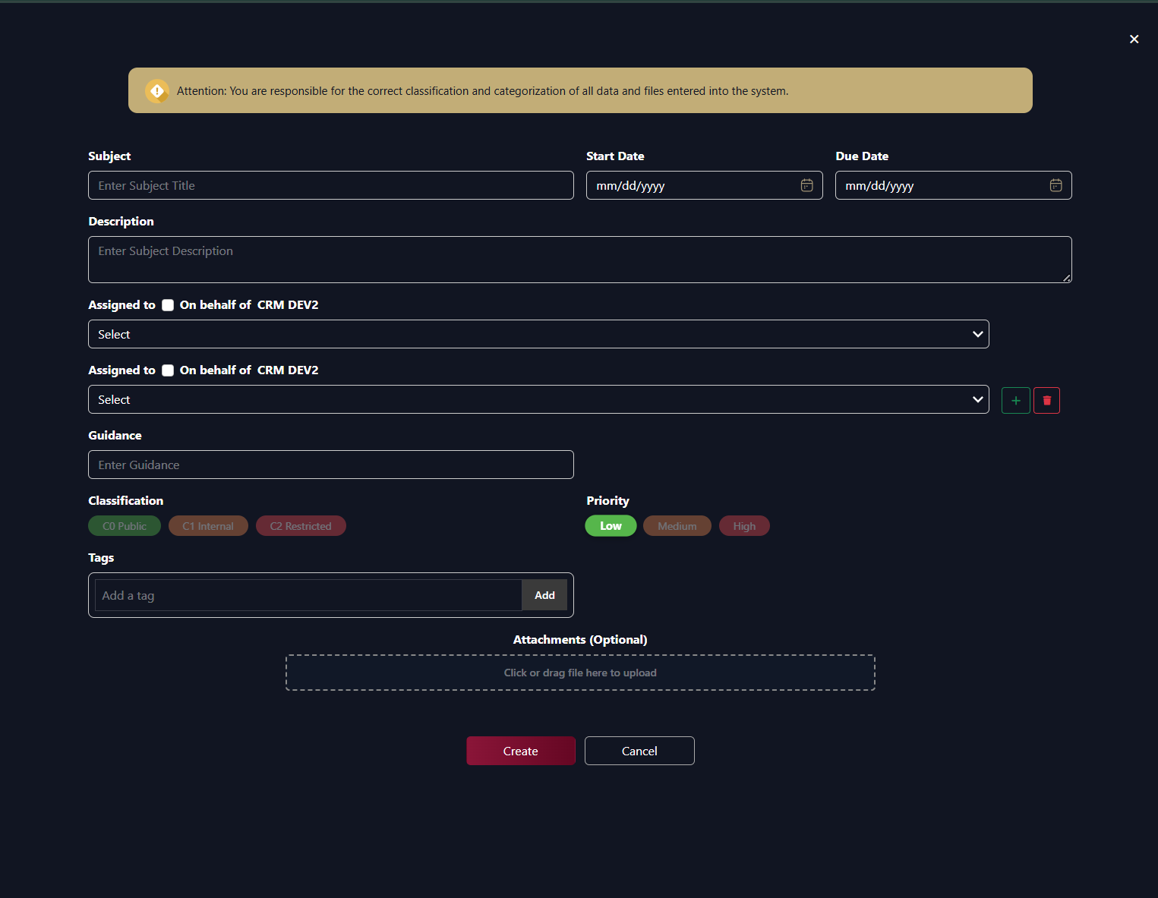
Classification Options:
- C0 Public (Green)
- C1 Internal (Orange)
- C2 Restricted (Red)
Priority Options:
- Low (Green)
- Medium (Orange)
- High (Red)
Attachments:
- Click or drag file to upload area
- Optional field
- Upload related files and documents
Actions:
- Create: To save the task
- Cancel: To exit without saving
Validation:
- Error message appears in top right if required fields are missing: "Please fill the required fields"
- Due Date must be after Start Date
"On behalf of" in New Task:
Overview
Secretaries can create tasks in two ways:
- On behalf of – The task is created as if the head (Department Head or Sector Head) created it. The head appears as Task Creator and Assign Department Head / Assign Sector Head.
- Not on behalf of – The task is created by the secretary. The secretary appears as Task Creator and Assign Secretary.
- In Both ways task show up in outgoing tasks so that secretary can monitor it

Department Secretary
When shown: When the user is a Department Secretary (belongs to a department and has secretary role).
Checkbox: "On behalf of [Department Head Name]"Assign to options (same in both modes):
- Other department secretaries
- Section heads (from the secretary’s department)
- Employees (from the secretary’s department)
"On behalf of" | Task Creator | Assign Department Head | Who can be assigned to
Checked | Department Head | Department Head | Section heads, employees
Unchecked | Secretary | (not set) | Section heads, employees
Behaviour:
- Checked: Task is created as if the Department Head created it. The Department Head is Task Creator and Assign Department Head. The task follows the Department Head’s workflow (e.g. next stage).
- Unchecked: Task is created by the secretary. The secretary is Task Creator and Assign Secretary. The task follows the secretary’s workflow.

Sector Secretary
When shown: When the user is a Sector Secretary (belongs to a sector only, no department).
Checkbox: "On behalf of [Sector Head Name]"Assign to options (same in both modes):
- Other sector secretaries
- Department heads (from the sector)
- Section heads (from the sector)
- All employees (from the sector)
"On behalf of" | Task Creator | Assign Sector Head | Who can be assigned to
Checked | Sector Head | Sector Head | Department heads, section heads, secretaries, employees
Unchecked | Secretary | (not set) | Department heads, section heads, secretaries, employees
Behaviour:
- Checked: Task is created as if the Sector Head created it. The Sector Head is Task Creator and Assign Sector Head. The task follows the Sector Head’s workflow (e.g. next stage).
- Unchecked: Task is created by the secretary. The secretary is Task Creator and Assign Secretary. The task follows the secretary’s workflow.

Task Dashboard Overview
The system automatically calculates and displays all your tasks across different categories on the dashboard.
Task Status Cards:
The dashboard displays five main task status cards with real-time counts:
- Completed Tasks (Green border)
  - Shows number of tasks you've finished
  - Includes both personal tasks and subtasks and assigned ones
- In Progress Tasks (Blue border)
  - Shows tasks currently being worked on
  - Tasks you've moved to "In Progress" status
- Not Started Tasks (Gray border)
  - Shows newly assigned tasks not yet begun
  - Tasks waiting for you to start
- Delayed Tasks (Red border)
  - Shows tasks past their due date
  - Only counts incomplete tasks with overdue dates
- Returned Tasks (Orange border)
  - Shows tasks rejected and sent back for revision
  - Tasks requiring modifications
Task Completion Progress Bar:
- Located below the status cards
- Shows percentage of completed tasks vs. total tasks
- Green progress bar with percentage displayed
- Checkmark icon indicates completion level
How Task Counts Are Calculated:
- Includes all personal tasks
- Includes all subtasks you're responsible for
- Updates in real-time as task statuses change
- Total count = Personal Tasks + Subtasks + Assigned Tasks
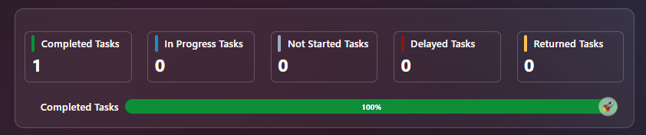

Mood Indicator
The mood indicator feature allows you to track and share your current work mood with the team.
Available Mood Options:
- Happy 😊 (Yellow border when selected)
- Anxious 😰 (Gray border when not selected)
- Enthusiastic 🤩 (Gray border when not selected)
How to Select Your Mood:
- Click on the desired mood emoji
- Selected mood is highlighted with yellow/golden border

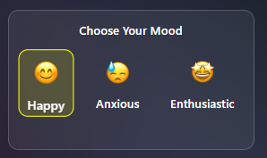

Dashboard
The dashboard provides a comprehensive and quick overview of all your tasks, statistics, and important updates, helping you track work progress and manage your workload effectively.
My Activities Section
Task Statistics Display:
Five circular progress indicators showing percentages:
- In Progress Tasks (Blue dot)
- Completed Tasks (Green dot)
- Not Started Tasks (Gray dot)
- Returned Tasks (Orange dot)
- Delayed Tasks (Red dot)
Task Count Tabs:
- Assigned Tasks (0): Tasks from others
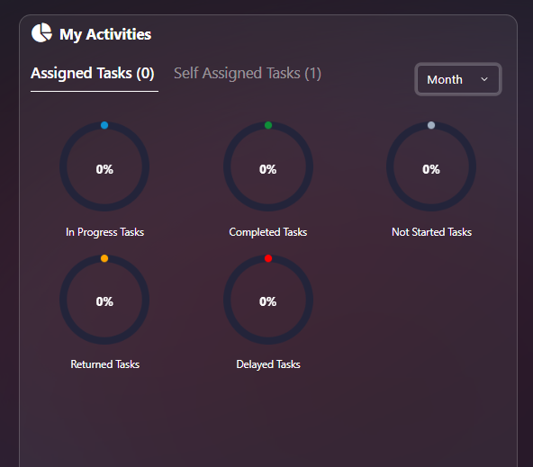
- Self-Assigned Tasks (7): Tasks you created
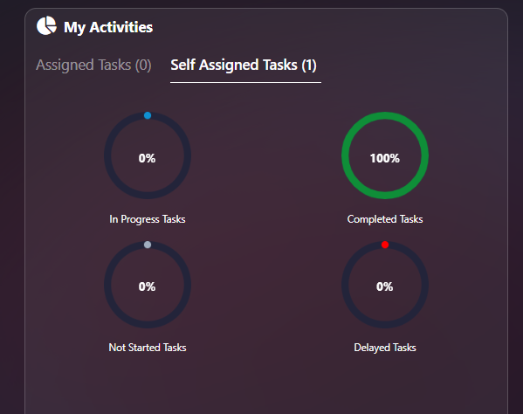
Time Filter:
- Month dropdown: Filter by specific month
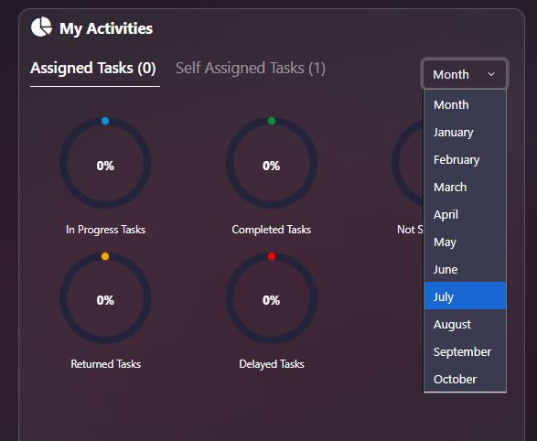

All Tasks
From the Home page, click on All Tasks to go to the "All Tasks" page and view tasks: "Not Started Yet - In Progress - Delivered".
View Options
List View / Calendar Toggle:
- List button: View tasks in kanban board format
- Calendar button: View tasks in calendar format (highlighted when selected)
List View
Three Status Columns:
- Not Started
  - Tasks have not yet begun
  - Quick create form at top
  - Task cards with due date badges
- In Progress
  - Tasks currently being worked on
  - Drag and drop tasks here to start
- Completed
  - Finished tasks
  - Status badges: "Completed" or "Pending Approval"
  - Checkmark icon indicates completion
Filter By:
- All Tasks: View all tasks assigned to you
- Personal: Tasks you created for yourself
- Sub Tasks: Tasks that are part of a larger parent task
- Assigned Tasks: Tasks assigned to you by others
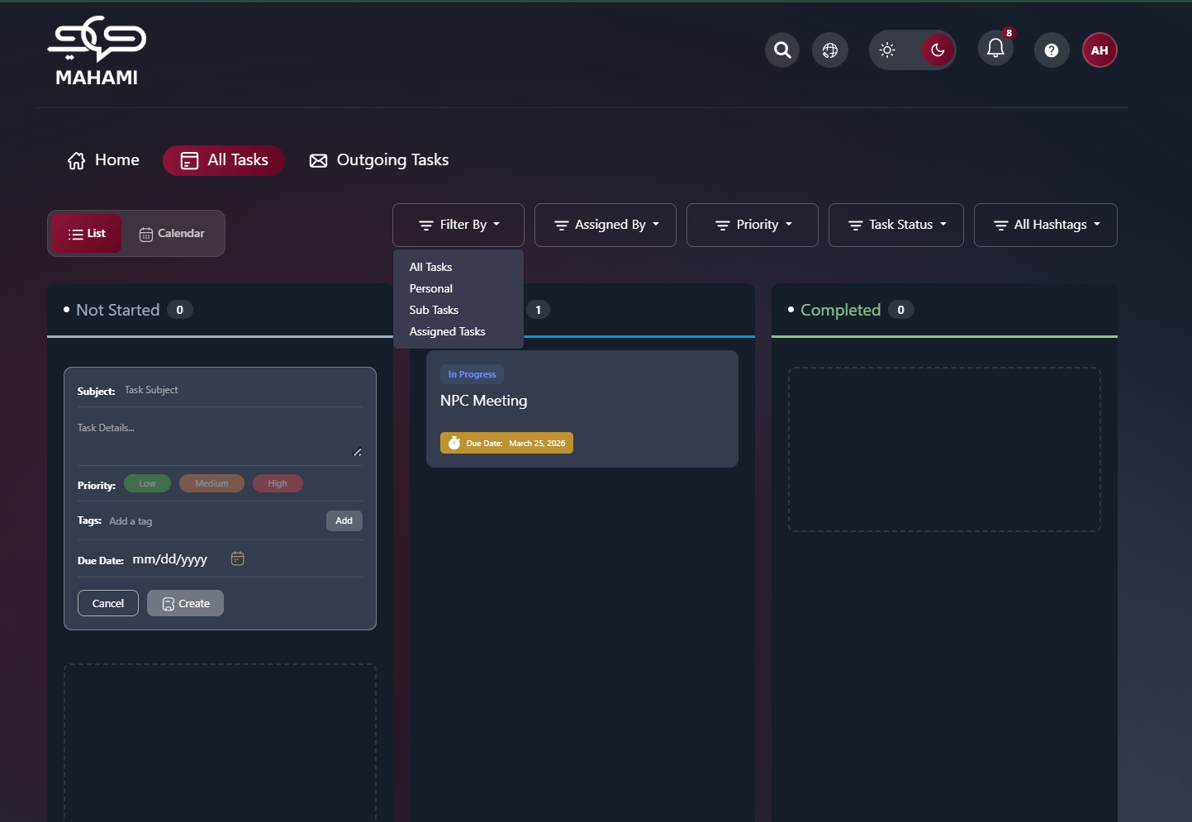
Assigned By: Filters tasks based on the user who originally assigned the task to you, allowing you to view tasks received from a specific manager
Priority filter: Narrows the task list by importance. Choose one or leave as “Priority” to see all.
- High
- Medium
- Low
Task status filter: Narrows the list by task state. Choose one option.
- All Status
- Not Started
- In Progress
- Pending Approval
- Completed
- Delayed
- Pending Delegation
All hashtags Filter: Narrows the list by one or more hashtags (tags). Default is “All Hashtags” (no filter). Open the control to pick hashtags; the list shows tasks that have at least one selected hashtag.
- Options are listed in the dropdown (e.g. #tag1, #tag2, …).
- You can select multiple hashtags.
- Use “Select all” / “Clear all” to quickly change the selection.
Quick Create Task:
- Subject: Enter task title (required)
- Task Details: Add description
- Priority: Low (green), Medium (orange), High (red)
- Due Date: Select deadline (mm/dd/yyyy format)
- Create button: Save new personal task
- Cancel button: Discard changes
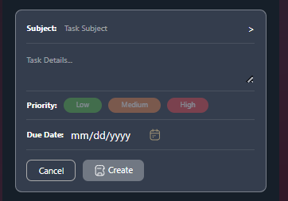
Personal Task Required Fields:
- Subject* (Required)
- Priority* (Required)
- Due Date* (Required)
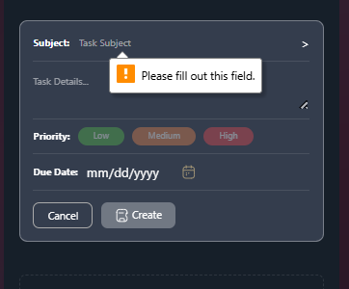
Task Cards Display:
- Task title/subject
- Due date badge (orange with fire icon if approaching)
- Status indicator
- Color-coded borders based on priority
- Action buttons (top right):
- Delete button 🗑️: Remove the task permanently
- Update button ✏️: Edit task details
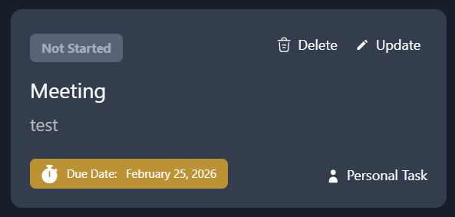
Personal Tasks vs. Subtasks:
Identifying Subtasks:
- Subtasks have a specific icon/logo to differentiate them from regular tasks
- Indented under parent task in list view
- Linked to parent task in task details
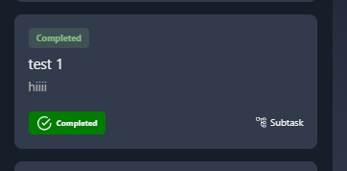
Creating Subtasks:
- From personal task, click "Add Subtask" option
- Required field: Subject only
- Due Date: Optional - if not specified, automatically inherits parent task's due date
- All other fields optional
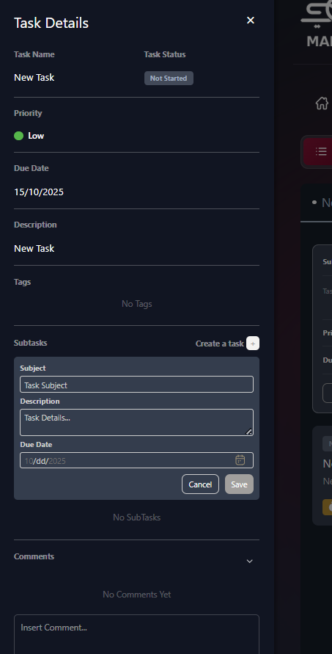
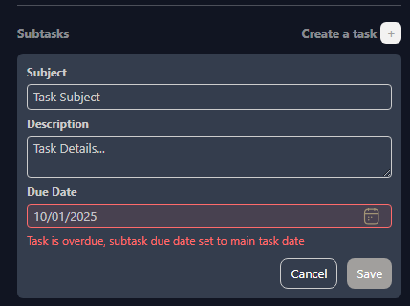
Two Ways to Complete Subtasks
Method 1: Complete Subtasks Individually
- Open the subtask
- Drag to "Completed" column
- Add completion notes
- Mark as complete
Method 2: Automatic Completion via Parent Task
- When you mark the parent task as "Completed"
- All associated subtasks automatically change to "Completed" status
- Saves time when entire project is finished
- Note: Review all subtasks before completing parent task
Calendar View
Three Calendar Formats:
      - Week View
  - Shows one week (Oct 12-18, 2025)
  - Hourly time slots (6am-6pm+)
  - Tasks displayed on specific days
  - All-day tasks shown at top
  - Navigation arrows to move between weeks
  - Today button: Jump to current date
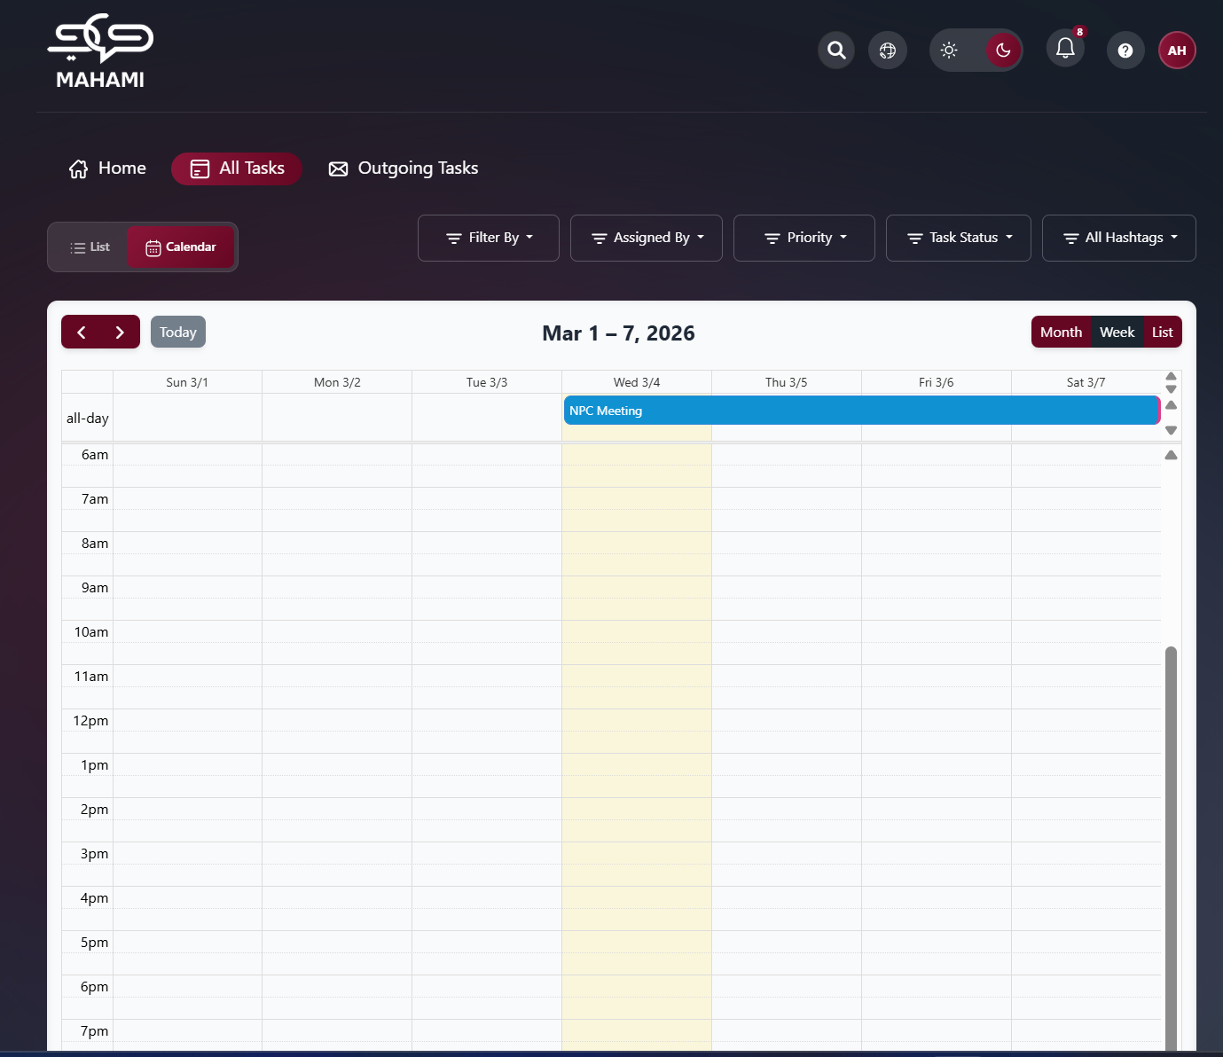
      - Month View
  - Shows full month (October 2025)
  - Tasks displayed on their due dates
  - Multiple tasks per day shown as stacked cards
  - Color-coded task cards:
- Green: Completed tasks with checkmark
- Gray: Not started tasks
  - Day numbers in corners
  - Current day highlighted (yellow background)
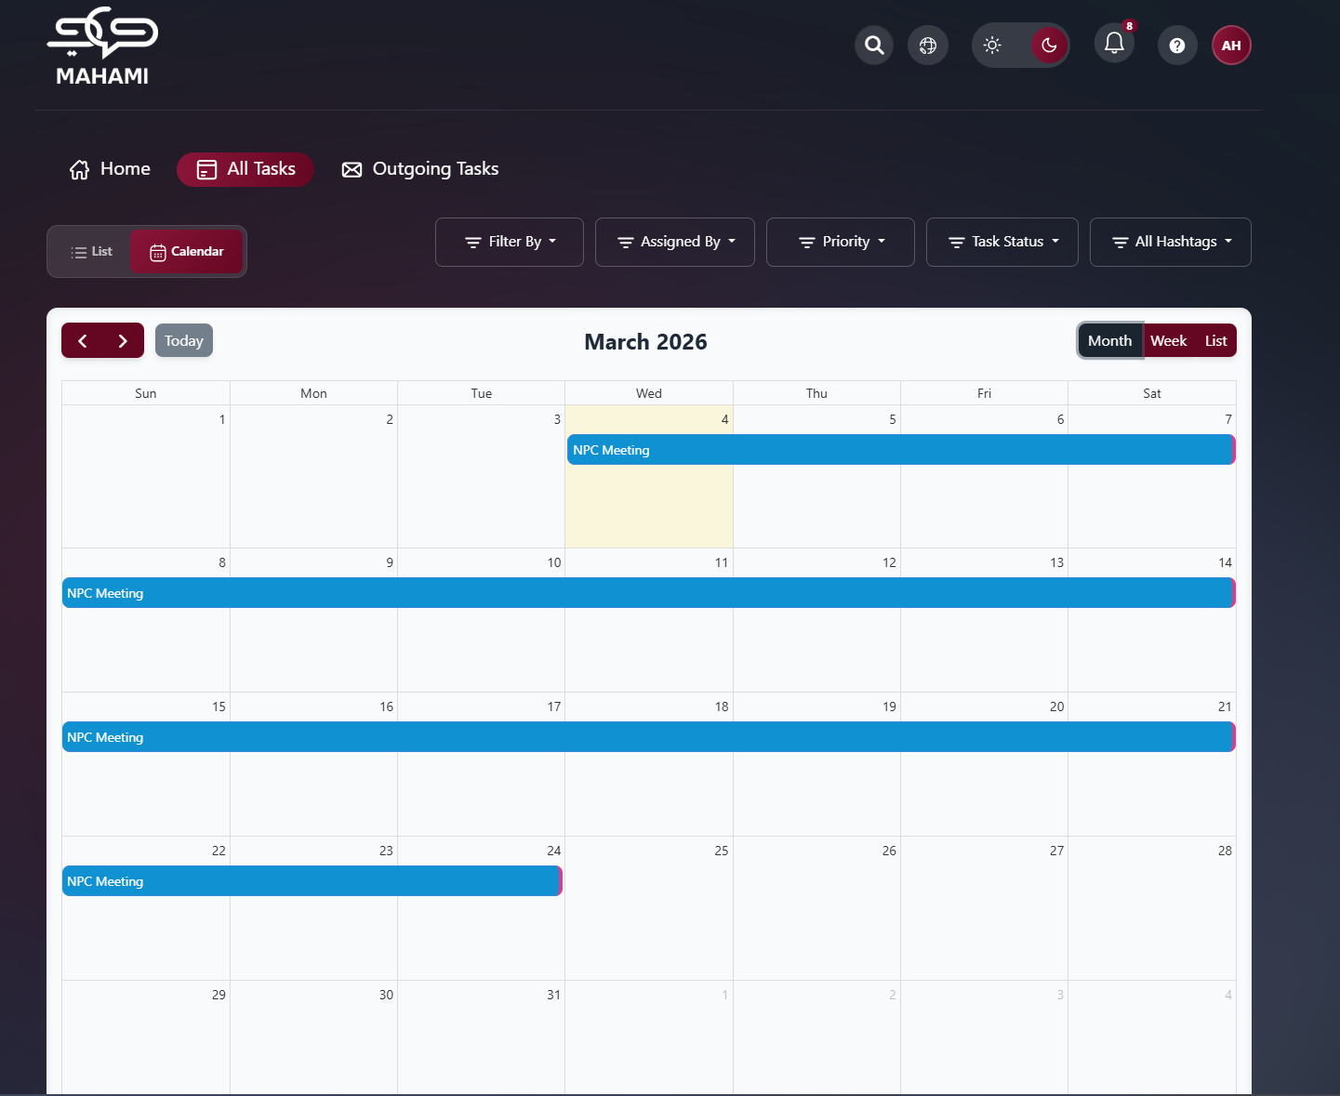
      - List View (Calendar Style)
  - Shows specific date
  - All-day section at top
  - Clean daily agenda format
  - Tasks listed with checkmarks
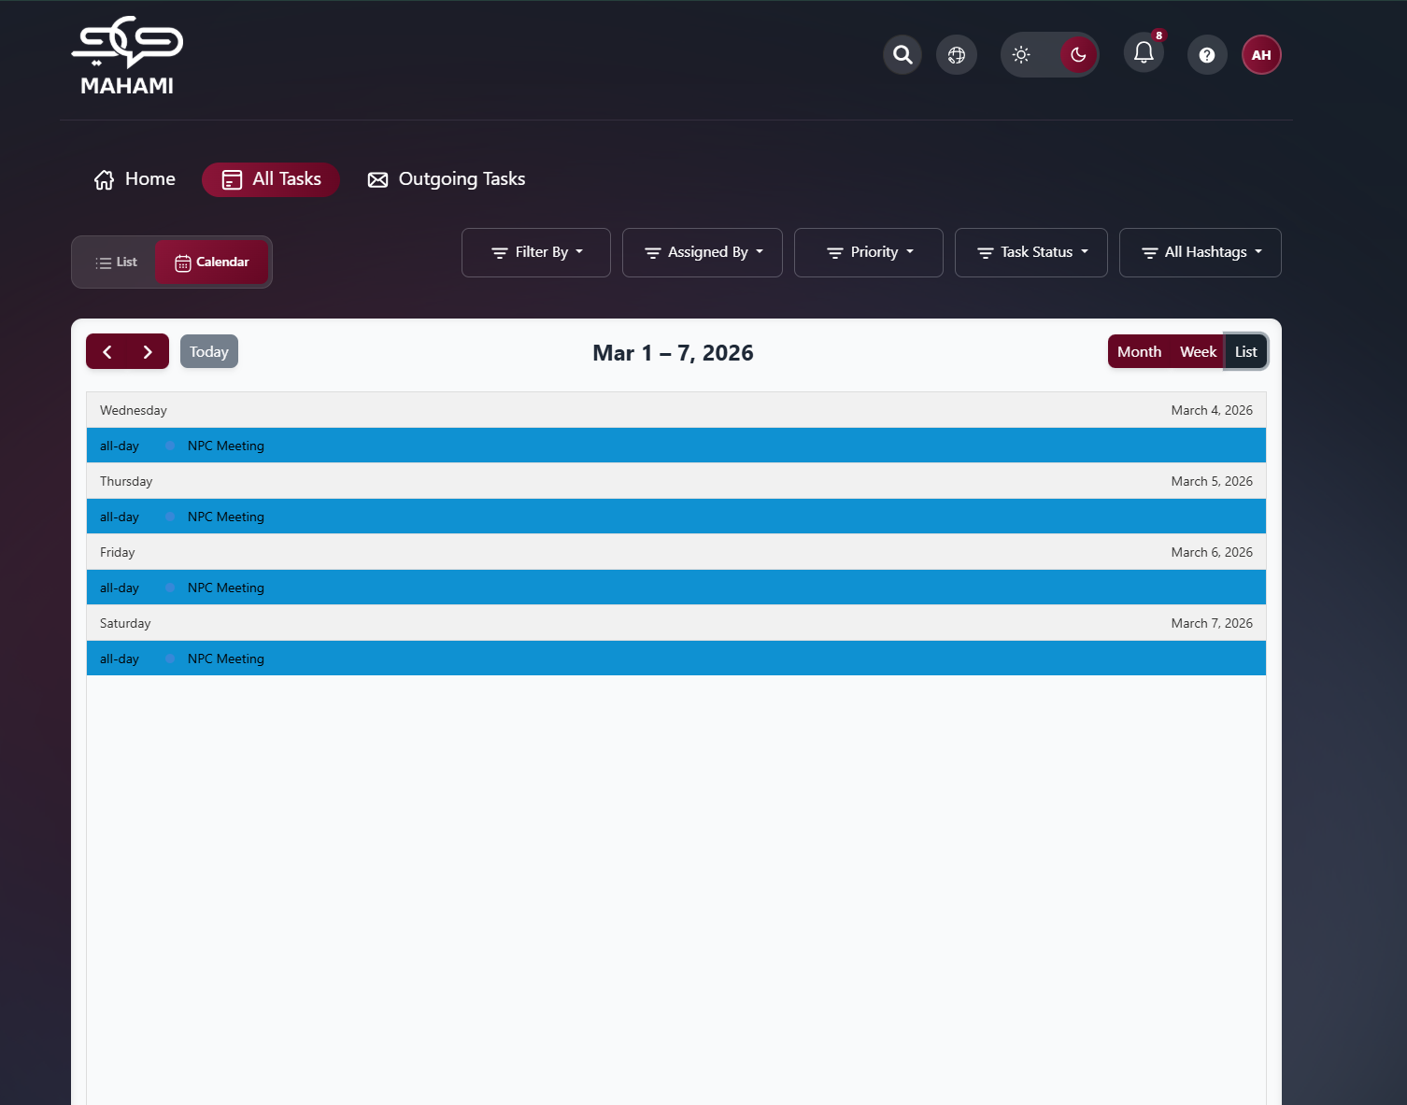
View Toggle Buttons:
- month: Monthly calendar view
- week: Weekly schedule view
- list: Daily list view
Calendar Features:
- Click on task to view details
- Tasks color-coded by status
- Checkmark indicates completed tasks
- Easy visual planning of workload

Outgoing Tasks
Click on Outgoing Tasks from the top navigation bar to view all tasks you have assigned to others.
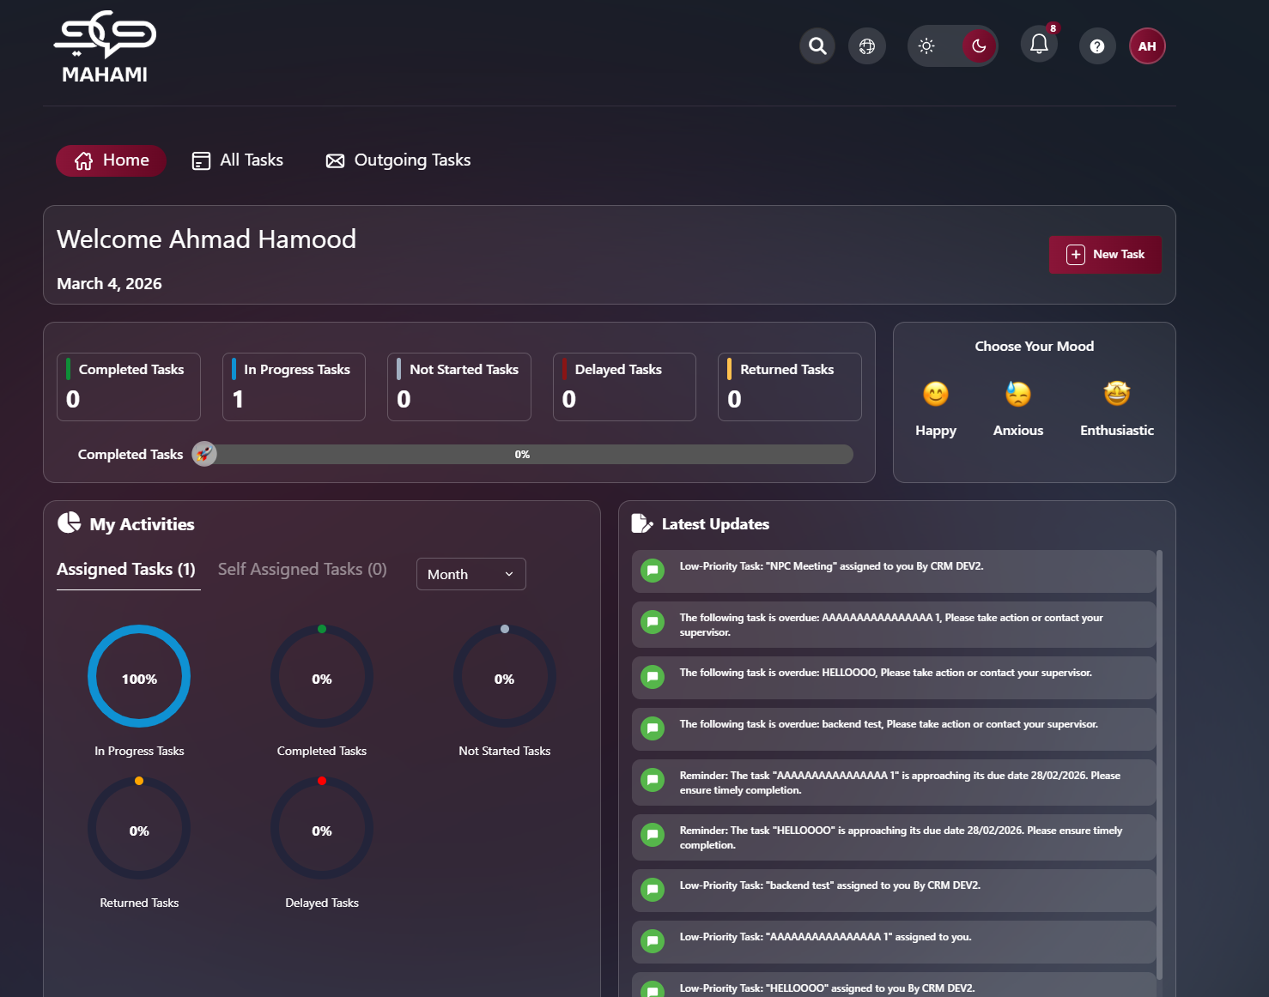
Page Overview
The Outgoing Tasks page displays all tasks you have created and assigned to team members in a table format, allowing you to track their progress and manage assignments.

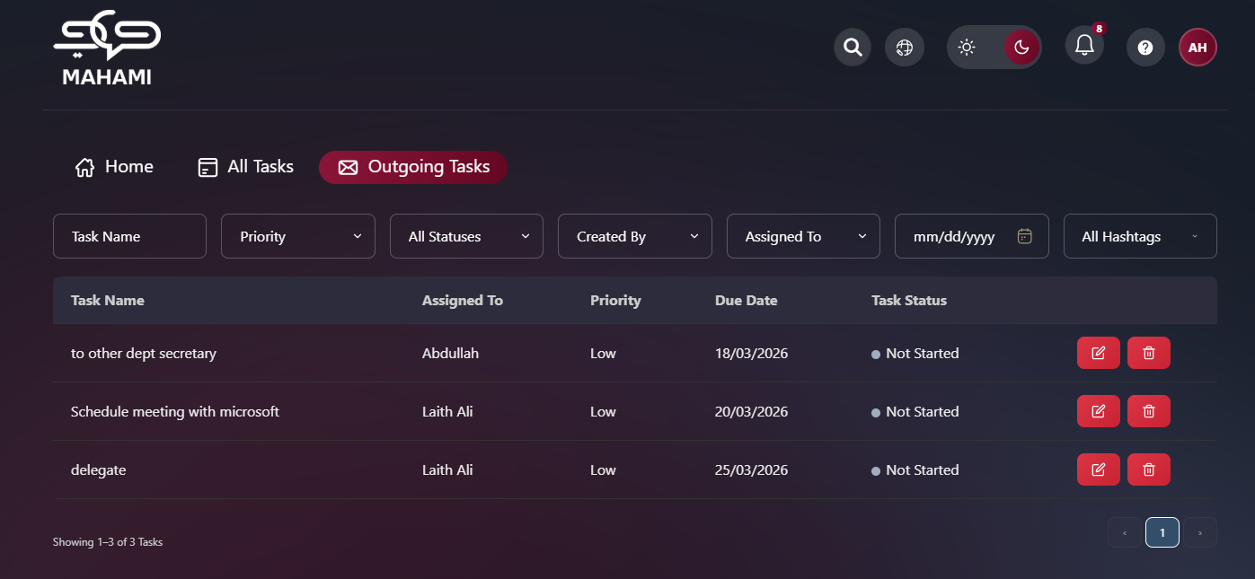
Filter and Search Options
Date Filter:
- Click on date field (mm/dd/yyyy format)
- Opens calendar popup
- Select specific date or date range
- Shows current month (October 2025)
- Navigation arrows to move between months
- Clear button: Remove date filter
- Today button: Jump to current date
- Current date highlighted in blue

Status Filter:
- All Statuses dropdown: Shows all task statuses by default
- Filter options:
- All Statuses (highlighted in blue when selected)
- Not Started
- In Progress
- Pending Approval
- Completed
- Delayed
- Pending Delegation
Task Name:
- Allows searching for a task by entering part or all of the task title.
The system performs a partial match search, meaning you can type a keyword instead of the full task name.
Priority:
- Filters tasks based on their assigned priority level (e.g., High, Medium, Low).
This helps focus on urgent tasks or review lower-priority items when needed.

Created By:
- Displays tasks based on the user who originally created them.
This is useful when tracking tasks initiated by a specific manager or employee.
Assigned To:
- Filters tasks according to the current assignee.
This allows managers to quickly view tasks assigned to a specific department head, section head, or employee.
All Hashtags:
- Filters tasks based on associated hashtags or tags.
This enables categorization and quick grouping of related tasks (e.g., project-based tags, operational categories, or special initiatives).

Table Columns
Task Name:
- Subject/title of the assigned task
- Clickable to view task details
Assigned To:
- Name of person responsible for the task
- Examples: "CRM DEV2", "Moh Second"
Priority:
- High, Medium, or Low priority level
- Displayed as text
Due Date:
- Deadline for task completion
- Format: dd/mm/yyyy
- Example: "23/10/2025"
Task Status:
- Status with color-coded indicator:
- Blue dot: In Progress
- Gray dot: Not Started
- Other status indicators as applicable
Actions:
- Red trash icon to delete task (on right side of each row)
- Red Pencil icon to edit the task (on the right side of each row)
- Note: Only task creators can edit or delete tasks except for secretaries, they are able edit and delete tasks that was created by them on behalf of their managers. Pending Approval (Delivered) and Completed tasks cannot be deleted nor edited
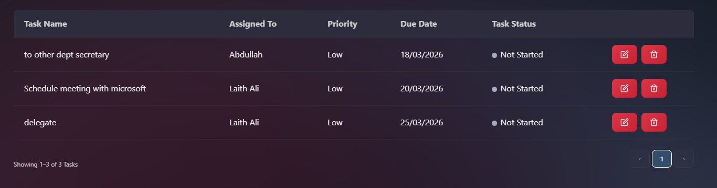

Pending Delegation Approval (How it works):
The Pending Delegation Approval process is triggered when an Employee requests to delegate an assigned task to another employee within the same Sector, Department, and Section. Only employees are permitted to initiate delegation requests.
Once a delegation request is submitted, the approval request is routed to the appropriate manager based on the original assignment hierarchy of the task. The approval authority is determined by the most recent managerial level in the assignment chain prior to the employee.
Approval Routing Logic
- If the Sector Head assigned the task directly to the Employee
Assignment chain:
Sector Head → Employee
→ The delegation request is sent to the Sector Head for approval.
- If the Sector Head assigned the task to the Head of Department, who then assigned it to the Employee
Assignment chain:
Sector Head → Head of Department → Employee
→ The delegation request is sent to the Head of Department for approval.
- If the Sector Head assigned the task to the Head of Department, who assigned it to the Head of Section, who then assigned it to the Employee
Assignment chain:
Sector Head → Head of Department → Head of Section → Employee
→ The delegation request is sent to the Head of Section for approval.
- If the Sector Secretary or Department Secretary assigned task (not on behalf) directly to Employee
Assignment chain: Secretary Employee
→ The delegation request is sent to the Secretary
In summary, the delegation approval request is always routed to the direct managerial level that assigned the task to the employee.
Approval Method
The designated approver receives a notification containing two action buttons:
- Approve
- Reject
Alternatively, the approver may review and process the request from the Task Details page within the Outgoing Tasks section.
The task remains in Pending Delegation Approval status until a decision is made.
Note: Delegated Tasks cannot be moved to “Completed” until approved/rejected.
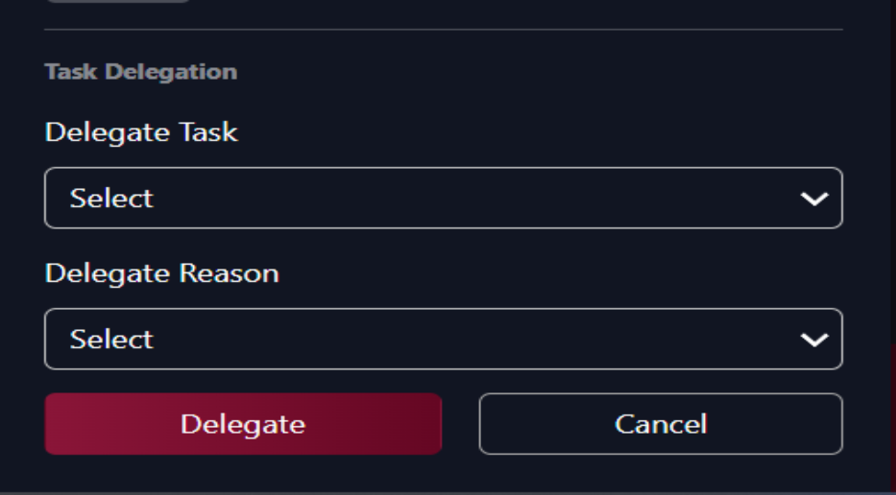
Employee view: Delegation Form
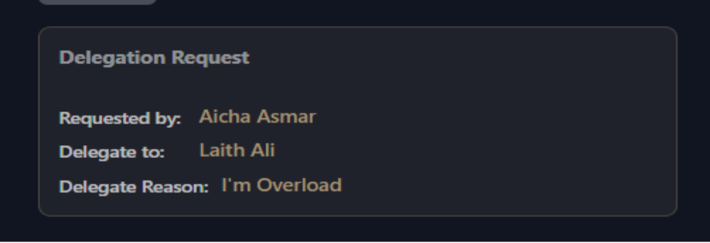
Employee view: Delegation Info appears after request

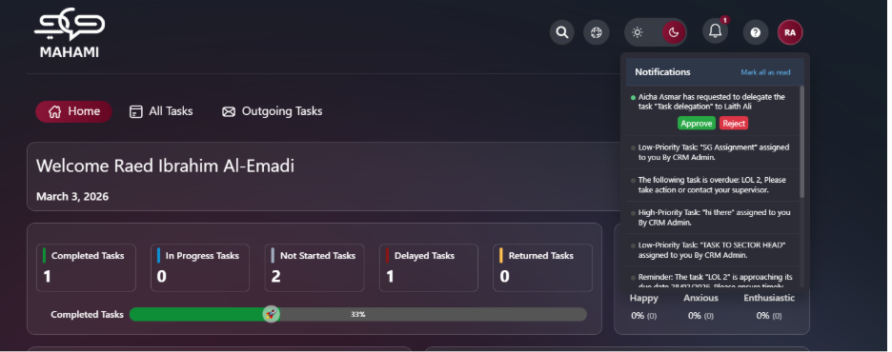Manager view: receives notification for delegation approval

Manager view: Task status changes to Pending Delegation

