
Task Management System



User Manual

Prepared by

Table of Contents
1. Version History 3
2. Reviewers 3
3. Approvers 3
4. Introduction 4
5. Definition of the System 4
6. System Functionality 4
7. Workflow and Available Actions for President/Secretary General 4
7.1 Task Creation and Initial Assignment 4
7.2 Sector Head Level - First Decision Point 6
7.3 Head of Department Level - Second Decision Point 8
7.4 Section Head Level - Third Decision Point 9
7.5 Task Execution Phase 10
7.6 Multi-Level Review and Approval Process 11
7.7 Types of Tasks in the System 13
7.8 Task States and Management 14
7.9 Support Features for President/Secretary General 15
7.10 Tips for Efficient System Use 16
8. Mahami App 17
8.1 Login 17
8.1.1 Access the System 17
8.2 Home 18
8.3 Outgoing Tasks 38

Version History
Date | Author | Version | Change Reference
September 29, 2025 | Abdullah Shehata | V1.0 | Initial Version
October 16, 2025 | Sirine Hammad | V1.1 | Second Version

Reviewers
Name | Position | Version Approve | Date
Hussein Chamseddine | Project Manager | V1.0

Approvers
Name | Position | Version Approve | Date

President/ Secretary General Guide

Introduction
This system aims to provide a comprehensive and integrated solution for task management by facilitating and simplifying all stages related to creating, modifying, tracking, and evaluating task results. The system also focuses on enhancing workflow efficiency and ensuring tasks are executed in an organized and effective manner.
One of the primary objectives of this project is to address current challenges and problems users face in traditional systems, whether in terms of slow performance, poor coordination between teams, or difficulty accessing task-related information.
Additionally, the system seeks to improve user experience through an easy-to-use interface, providing accurate analytical reports, and smart notifications and alerts that help track work progress and ensure completion within the specified time with the ability to reassign and delegate tasks.

Definition of the System
Authorized employees can access the system through the following link:
Mahami
Note: The company email username and password are used to log into the system.

System Functionality
The system provides a set of tools for efficient task management. Here are its main functions:
- Create Tasks: You can create personal tasks or assign them to others
- Track Tasks: The system provides dedicated pages for tracking outgoing tasks or personal tasks
- Team Management: You can monitor your team's performance through a comprehensive dashboard
- Advanced Details: The system supports adding subtasks, attaching files, and adding comments
- Notifications: The system sends instant notifications about new tasks and updates

Workflow and Available Actions for President/Secretary General
This document defines the comprehensive workflow for creating, assigning, executing, and approving tasks within the task management system at the highest organizational level, which includes roles such as President/Secretary General, Sector Heads, Heads of Departments, Section Heads, and Employees.

Task Creation and Initial Assignment
As the President/Secretary General, you initiate the task management workflow:
Creating a Task:
- Click on "New Task" from the top bar or Home page
- The task creation process begins (orange start indicator)
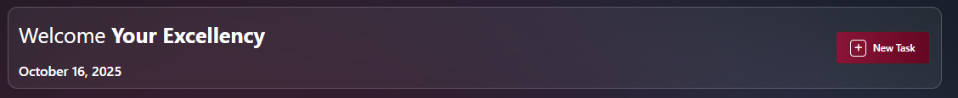
- Fill in all required task details:
  - Subject and description
  - Start date and due date
  - Priority level (High, Medium, Low)
  - Classification (Public, Internal, Restricted)
  - Attachments and guidance
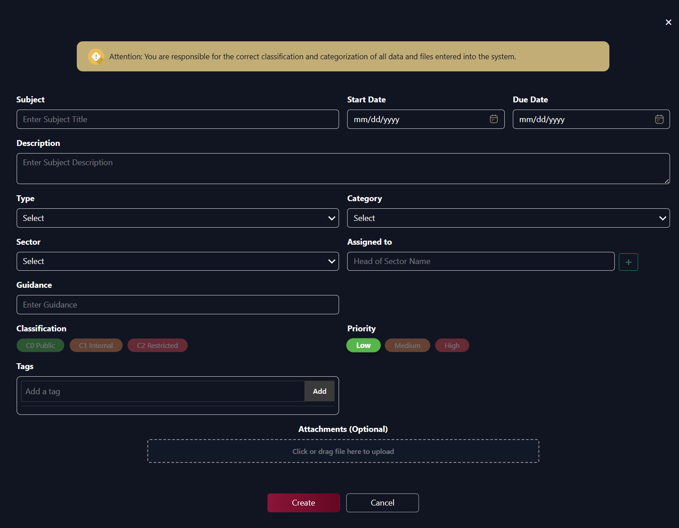
Initial Assignment to Sector Head:
- Select the appropriate Sector Head from the dropdown list
- Add clear strategic instructions and context
- Set priority and deadline
- Send instant notification 📧 to the assigned Sector Head
- Task appears in your "Outgoing Tasks" list for tracking
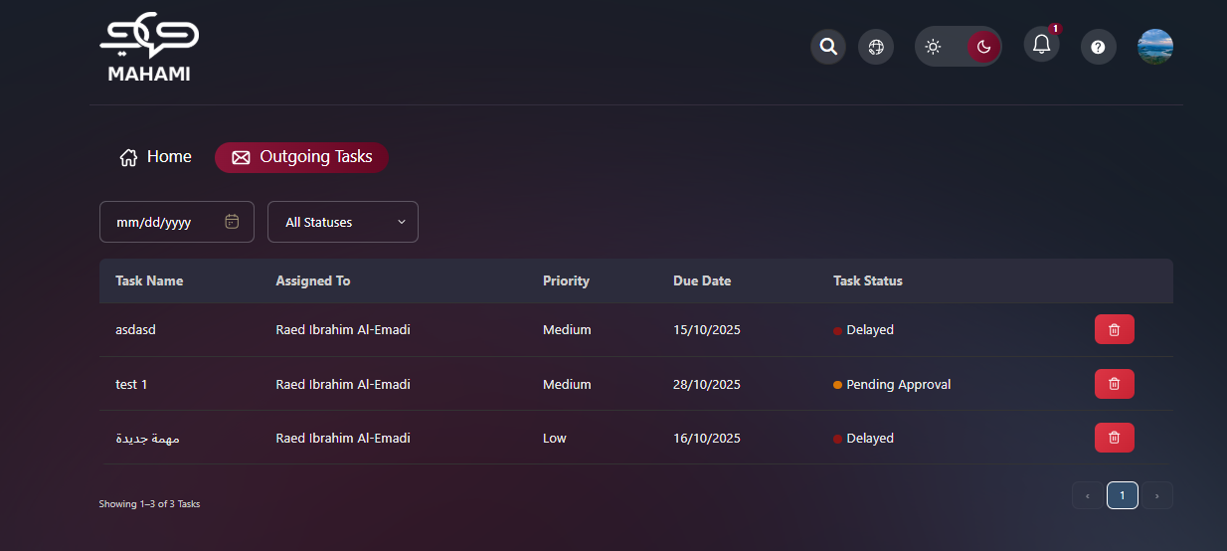

Sector Head Level - First Decision Point
Sector Head Receives Task from Secretary General
Notification and Access:
- Sector Head receives instant notification 📧 of new task assignment
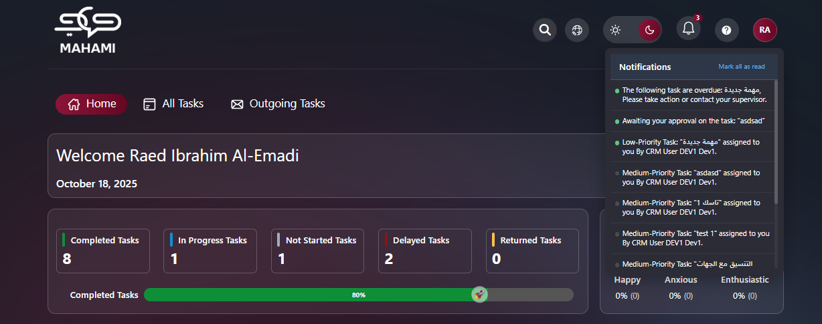
- Task appears in "All Tasks" list with status "Not Started Yet"
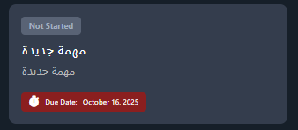
- Can access full task details by clicking on it
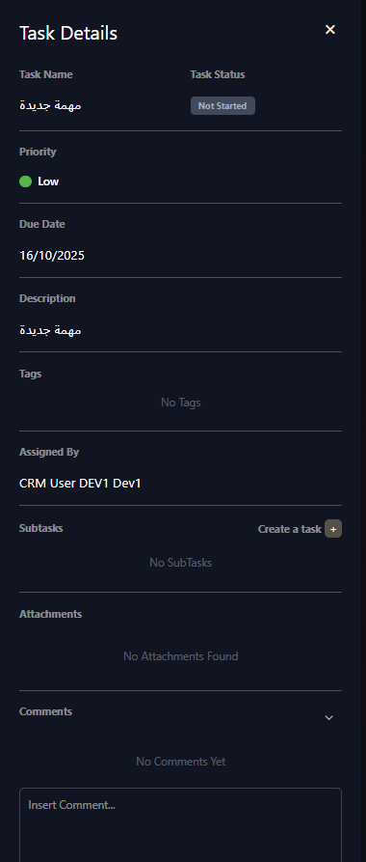
Sector Head Has Two Options:
Option 1: Execute Task Personally (Blue Path)
- Sector Head decides to handle the task themselves
- Drag and drop task to "In Progress" column
- Complete the work and move to "Delivered" status
- Task flows directly to execution phase
- Proceeds to Section Head review stage after completion
Option 2: Assign to Head of Department (Green Path)
- Select appropriate Head of Department based on:
  - Task nature and department expertise
  - Current workload
  - Required specialization
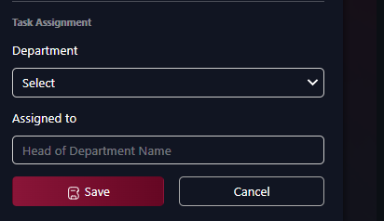
- Add specific instructions and guidance
- Set expectations and deadlines
- Send notification 📧 to Head of Department
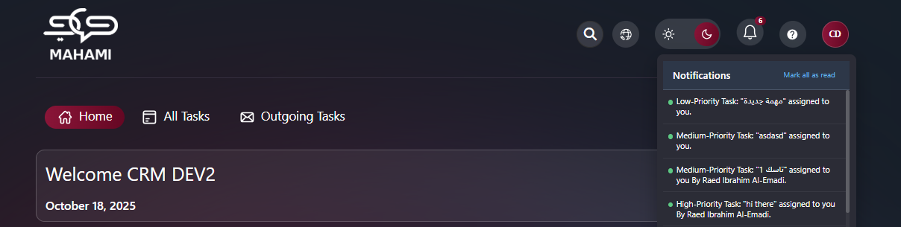
- Track progress in "Outgoing Tasks" list
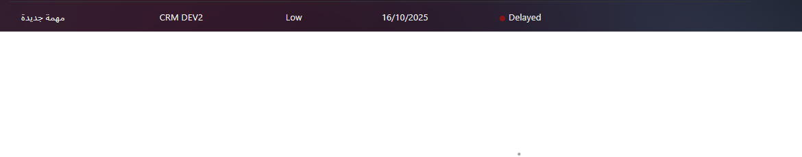

Head of Department Level - Second Decision Point
Head of Department Receives Task from Sector Head
Notification and Access:
- Head of Department receives instant notification 📧
- Task appears in their "All Tasks" list
- Can review full task details and instructions
Head of Department Has Two Options:
Option 1: Execute Task Personally (Blue Path)
- Head of Department handles the task directly
- Move task to "In Progress" status
- Complete work and deliver
- Flows directly to execution phase
- Proceeds to Section Head review after completion
Option 2: Assign to Section Head (Green Path)
- Select appropriate Section Head from their department
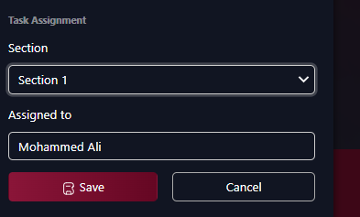
- Consider section expertise and workload
- Add detailed instructions
- Set clear expectations
- Send notification 📧 to Section Head
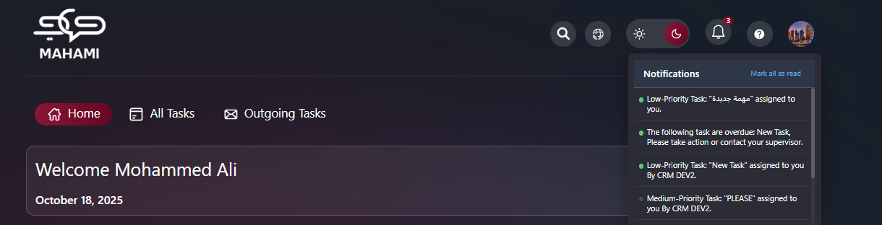
- Monitor through "Outgoing Tasks"

Section Head Level - Third Decision Point
Section Head Receives Task
Section Head Has Two Options:
Option 1: Execute Task Personally (Blue Path)
- Section Head executes the task themselves
- Update status to "In Progress"
- Complete and deliver
- Enters execution and review cycle
Option 2: Assign to Employee (Green Path)
- Select suitable employee from the section
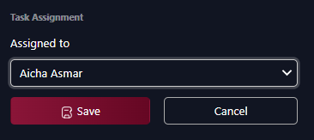
- Provide clear, detailed instructions
- Set expectations and timeline
- Send notification 📧 to employee
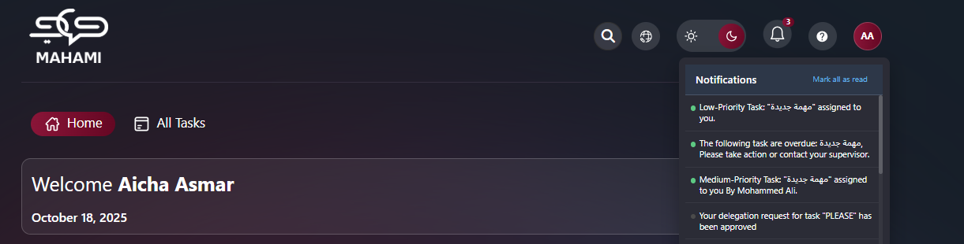
- Track progress
- Delegate the Task
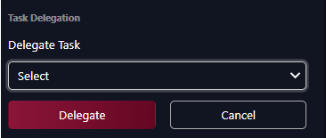

Task Execution Phase
Three Execution Paths Converge
At this stage, tasks are being executed by one of three roles:
1. Execute Task - Employee
- Employee completes assigned task
- Updates progress regularly
- Adds comments and uploads deliverables
- Moves to "Delivered" when complete
2. Execute Task - Section Head
- Section Head completes task personally
- Provides detailed work and documentation
- Submits for review
3. Execute Task - Head of Department
- Head of Department completes task directly
- Delivers comprehensive results
- Submits for approval chain
All three paths proceed to the review and approval cycle

Multi-Level Review and Approval Process
The task approval process consists of four review stages, each with the ability to approve or reject the submitted work.
Four-Stage Review Chain:
Stage 1: Section Head Review
- Reviews completed tasks from employees or self-executed work
- Approve: Task moves to Head of Department review
- Reject: Returns to executor with modification notes
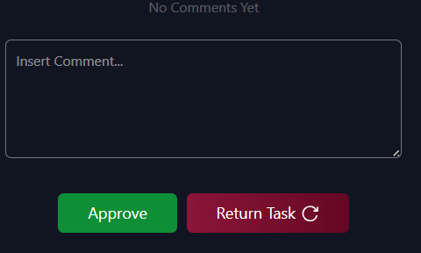
Stage 2: Head of Department Review
- Reviews tasks approved by Section Head
- Approve: Task proceeds to Sector Head review with performance evaluation
- Reject: Returns to Section Head level with detailed feedback
Stage 3: Sector Head Review
- Reviews tasks approved by Head of Department
- Approve: Task proceeds to Secretary General for final approval
- Reject: Returns to Head of Department with strategic feedback
Stage 4: Secretary General - Final Review
- Final review and approval authority
- 🟢 Approve: Task completed (طلب مكتمل) - End of workflow 🟠
- 🔴 Reject: Task incomplete (طلب معلق) - Returns to Sector Head level
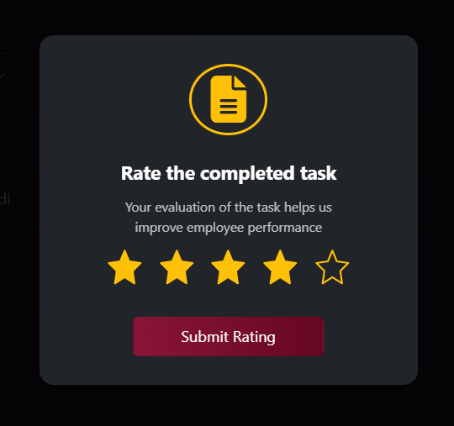

Types of Tasks in the System
Assigned Tasks:
- Tasks created and assigned to Sector Heads
- Strategic organizational initiatives
- Tracked through the "Outgoing Tasks" section
Personal Tasks:
- Self-Assigned Tasks
- Appear in “All Tasks” page
Subtasks:
- Components of larger strategic initiatives
- Tasks branching from a main task
- Ability to divide complex tasks into smaller, manageable parts

Task States and Management
Basic Task States:
Not Started Yet:
- Newly assigned tasks
- Awaiting initiation by assignee
- No action taken yet
In Progress:
- Tasks currently being executed
- Regular progress updates expected
- Continuous update of progress and notes
Delivered:
- Completed tasks awaiting presidential review
- Ready for final approval or modification
- All requirements met by assignee
Overdue:
- Tasks that missed the deadline
- Require immediate attention and escalation
- Flagged in red for high visibility
Pending Approval:
- Completed tasks awaiting presidential review and approval
- Critical decision point for organizational initiatives
- Requires executive action
Pending Delegation Approval:
- An employee or lower-level manager requested to delegate their task to someone else
- Requires approval from their direct supervisor
- Visible for monitoring purposes

Support Features for President/Secretary General
Executive Dashboard:
- Comprehensive overview of all organizational tasks across all sectors
- Cross-sector performance statistics and comparisons
- Strategic KPIs and organizational health metrics
- Real-time organizational performance indicators
Smart Notifications:
- High-priority task alerts requiring immediate attention
- Deadline warnings for critical strategic initiatives
- Status updates from all sectors and organizational levels
- Escalation notifications for overdue or at-risk tasks
- Completion notifications requiring presidential approval
Reports and Statistics:
- Organization-wide performance reports and analytics
- Sector-by-sector comparison and benchmarking
- Task completion statistics at all organizational levels
- Analysis of average execution times and efficiency metrics
- Strategic goal achievement tracking
- Quality ratings and performance trends
- Resource utilization across the organization
Organizational Management:
- Monitor performance of all Sector Heads
- Compare sector effectiveness and efficiency
- Identify organizational bottlenecks and systemic issues
- Strategic resource allocation insights and recommendations
- Evaluate overall organizational efficiency
Leaderboard and Recognition:
- View top performers across entire organization
- Recognition of excellence at all organizational levels
- Three categories: Quality Champion, Task Closer of the Week, Outstanding in Consistency
- Filter by department and section for granular analysis
- Champions section with weekly recognition messages

Tips for Efficient System Use
When Creating New Tasks:
- Clearly articulate strategic importance and business context
- Link to organizational vision, mission, and strategic goals
- Provide necessary background information and resources
- Define measurable success criteria and KPIs
- Set realistic but challenging deadlines
- Consider resource requirements and organizational capacity
When Assigning Tasks:
- Match task complexity to sector expertise and capability
- Consider current workload across sectors for balanced distribution
- Provide adequate authority, resources, and support
- Communicate expected standards and quality levels clearly
- Allow appropriate time for quality execution
- Include strategic context to ensure organizational alignment
When Reviewing Tasks:
- Evaluate against strategic objectives and organizational impact
- Focus on outcomes and value delivered, not just outputs
- Provide specific, constructive, and actionable feedback
- Recognize exceptional performance publicly and promptly
- Make timely decisions to maintain organizational momentum
- Consider organizational learning and continuous improvement opportunities
- Document lessons learned for future strategic planning
When Monitoring Progress:
- Conduct regular dashboard reviews (daily or weekly)
- Proactively intervene for delayed or at-risk strategic tasks
- Identify systemic issues, patterns, and root causes early
- Celebrate successes and share best practices across organization
- Use data and analytics to inform strategic decisions and adjustments
- Maintain open communication channels with all Sector Heads
- Review organizational morale and take action when needed
- Mahami App

  - Login
    - Access the System
      - Accessing the System URL
Click On The Provided link: Mahami
      - Login Credentials
Use your email and password (same as Outlook credentials).
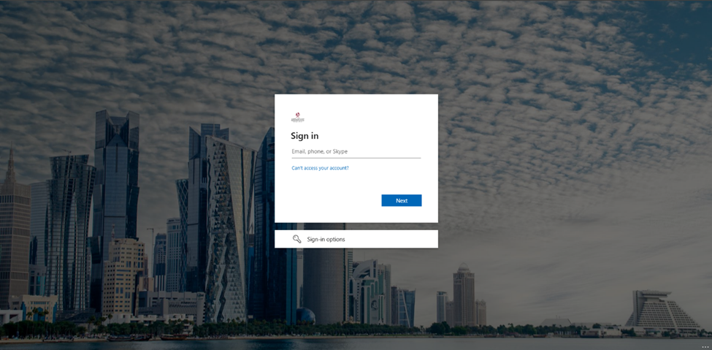

Home
After logging in, you are directed to the Home page.
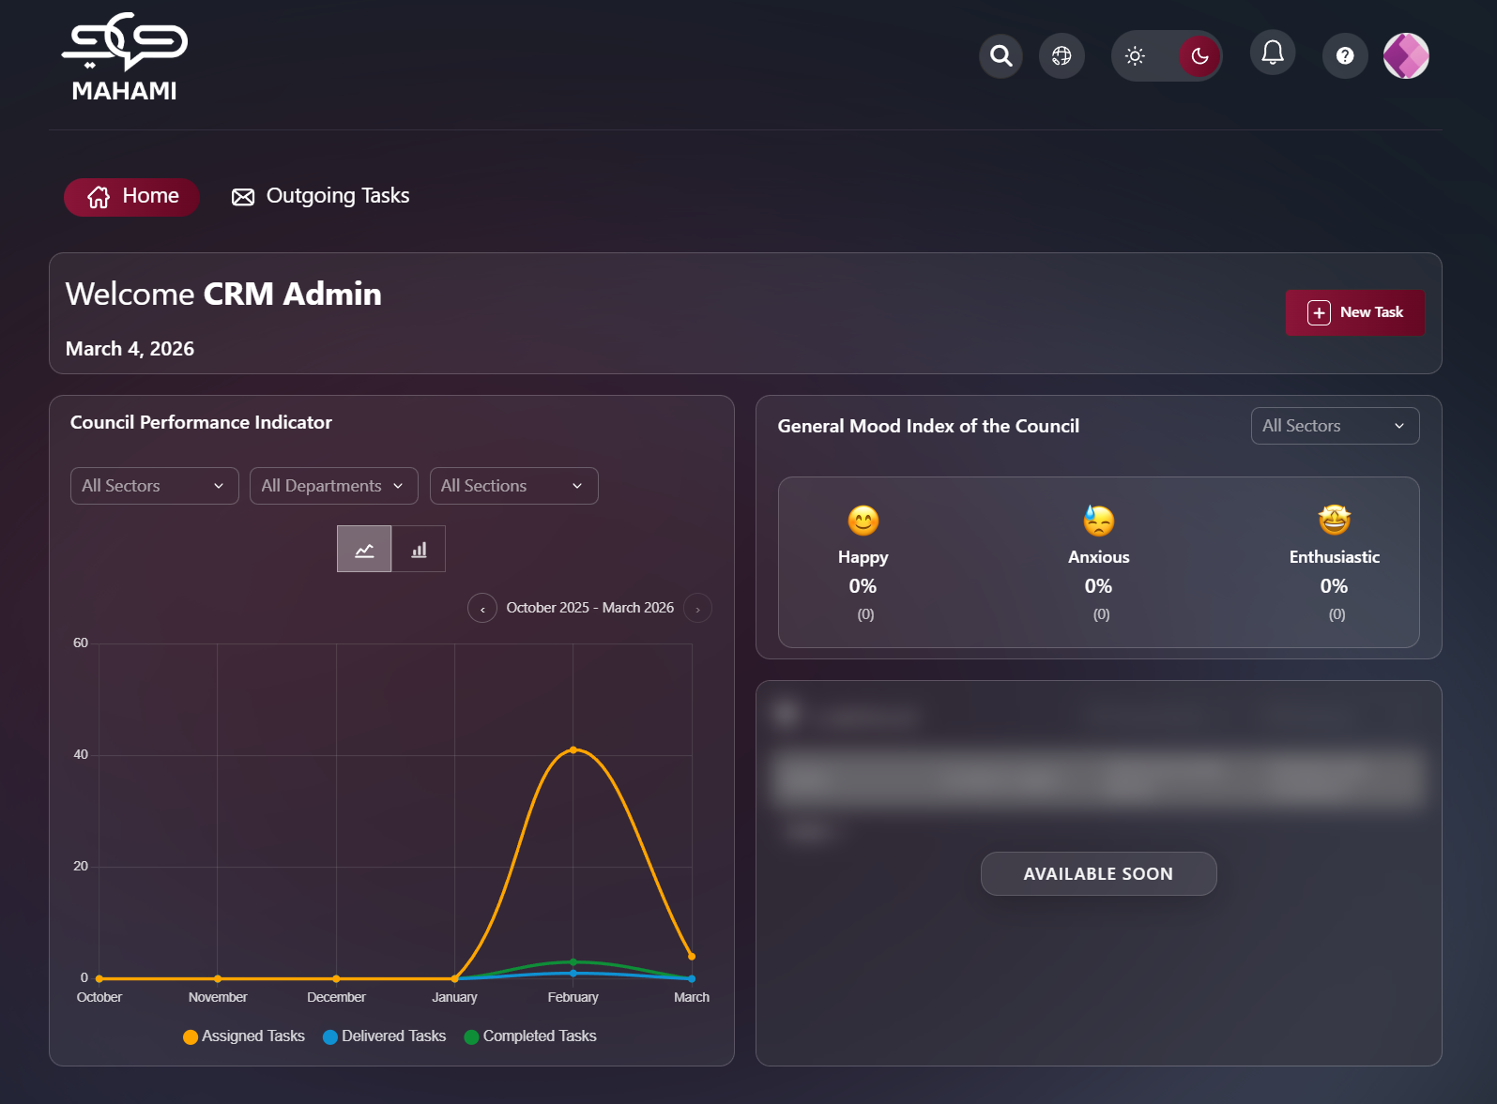

Profile Page
The profile page allows users to customize their account by uploading a personal photo, providing a personalized and comfortable user experience that suits their personal needs.
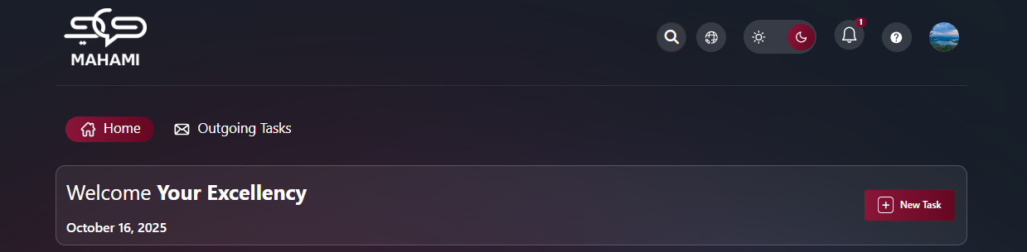
Default Avatar:
- When no photo is uploaded or after deletion, the system displays your initials
- Format: First letter of First Name + First letter of Last Name
- Unique color assigned automatically for visual distinction
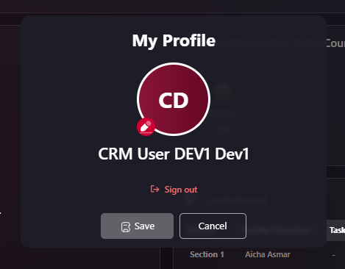
Uploading a Profile Picture:
- Click on profile icon → "My Profile"
- Click edit icon on avatar
- Select image file (JPG, PNG - Max 5MB)
- Crop if needed
- Click "Save"
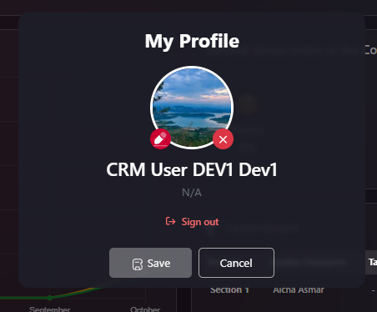
Deleting Your Profile Picture:
- Go to "My Profile"
- Hover over current picture
- Click delete icon (trash can/camera with X)
- Confirm deletion
- Click "Save"
- Profile reverts to initials avatar
Additional Profile Information:
- Full name displayed
- Department/Position (shows "N/A" if not configured)
- Sign Out button at bottom
- Save/Cancel buttons for changes

Help & Support
The Help & Support feature allows you to quickly submit questions, report issues, or request assistance directly to the support team.
Form Fields:
- Name: * Auto-filled from your profile
- Email Address: * Auto-filled with your company email
- Subject: * Brief description of your issue
- Message: * Detailed explanation of the problem
Actions:
- Send Message: Submit support request
- Cancel: Close without sending
Response Time:
- 24-48 business hours via email
Common Issues:
- Technical problems
- Feature questions
- Access issues
- Training requests
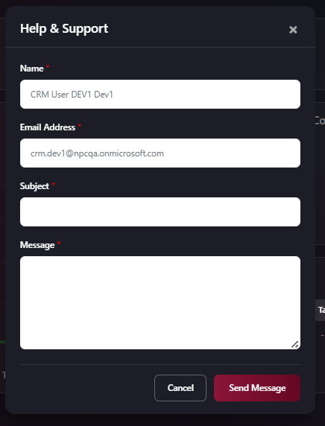

Notifications
From the top right, click on Notifications to display the notifications list.
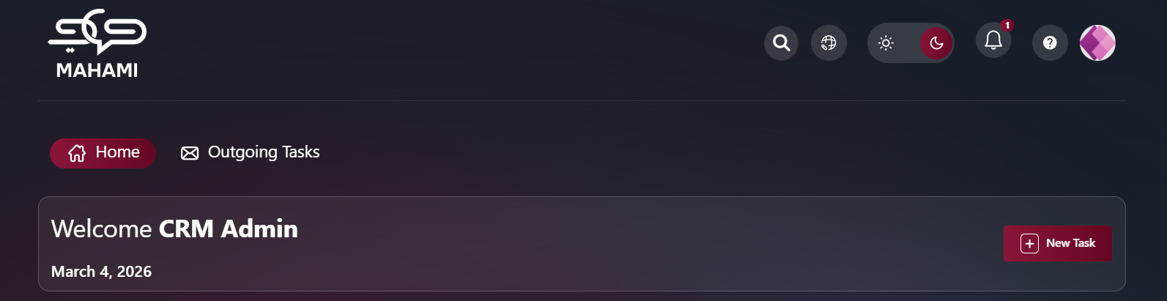
Notification Status Indicators:
- Green dot: New/unread notification
- Gray: Read notification after clicking or marking as read
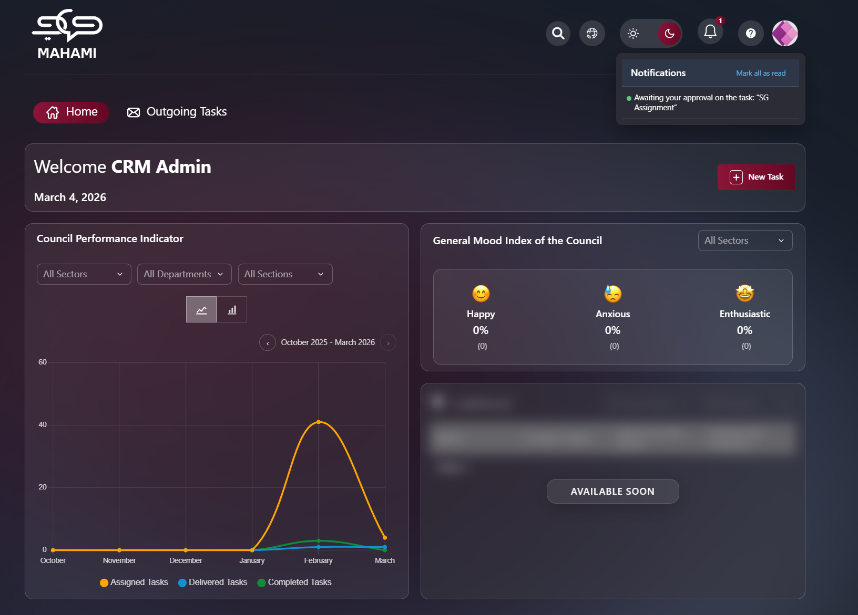
Clickable Notifications:
- Click on any notification to view the related task directly
- Automatically marks notification as read (turns gray)
- Takes you to the task details page
Managing Notifications:
- Mark All as Read: Click button at top to mark all notifications as read
- All green indicators turn gray
- Clears notification count badge
Notification Types:
- New task assigned
- Task status changed
- Deadline approaching
- Comment added
- Task completed
- Approval required
- Delegation requests

Lighting Mode
Toggle between day and night mode using the button at the top left.
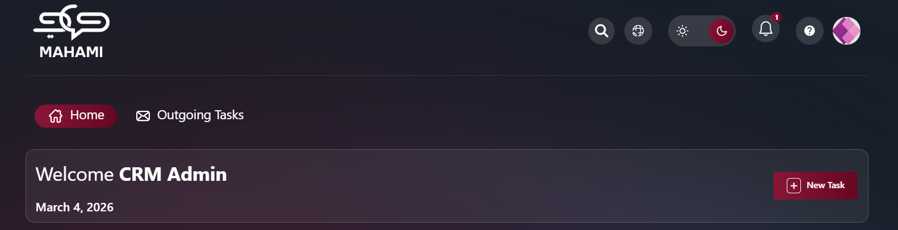

Night mode
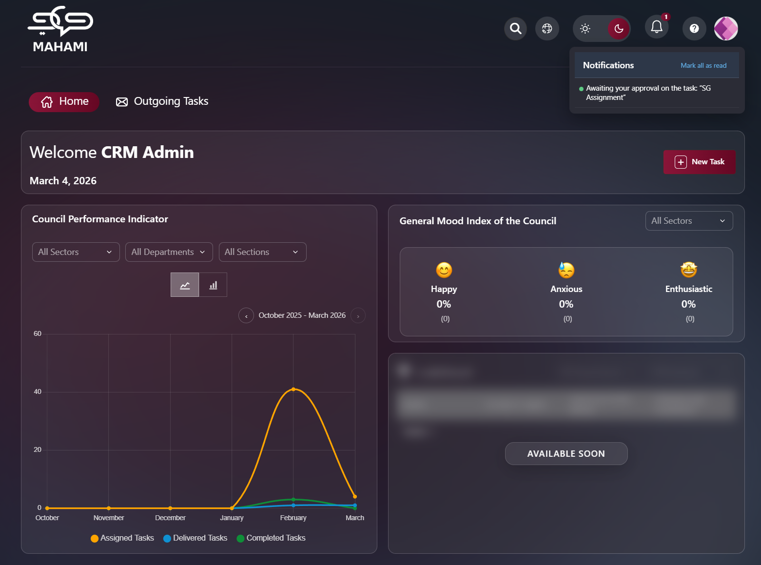

Light Mode
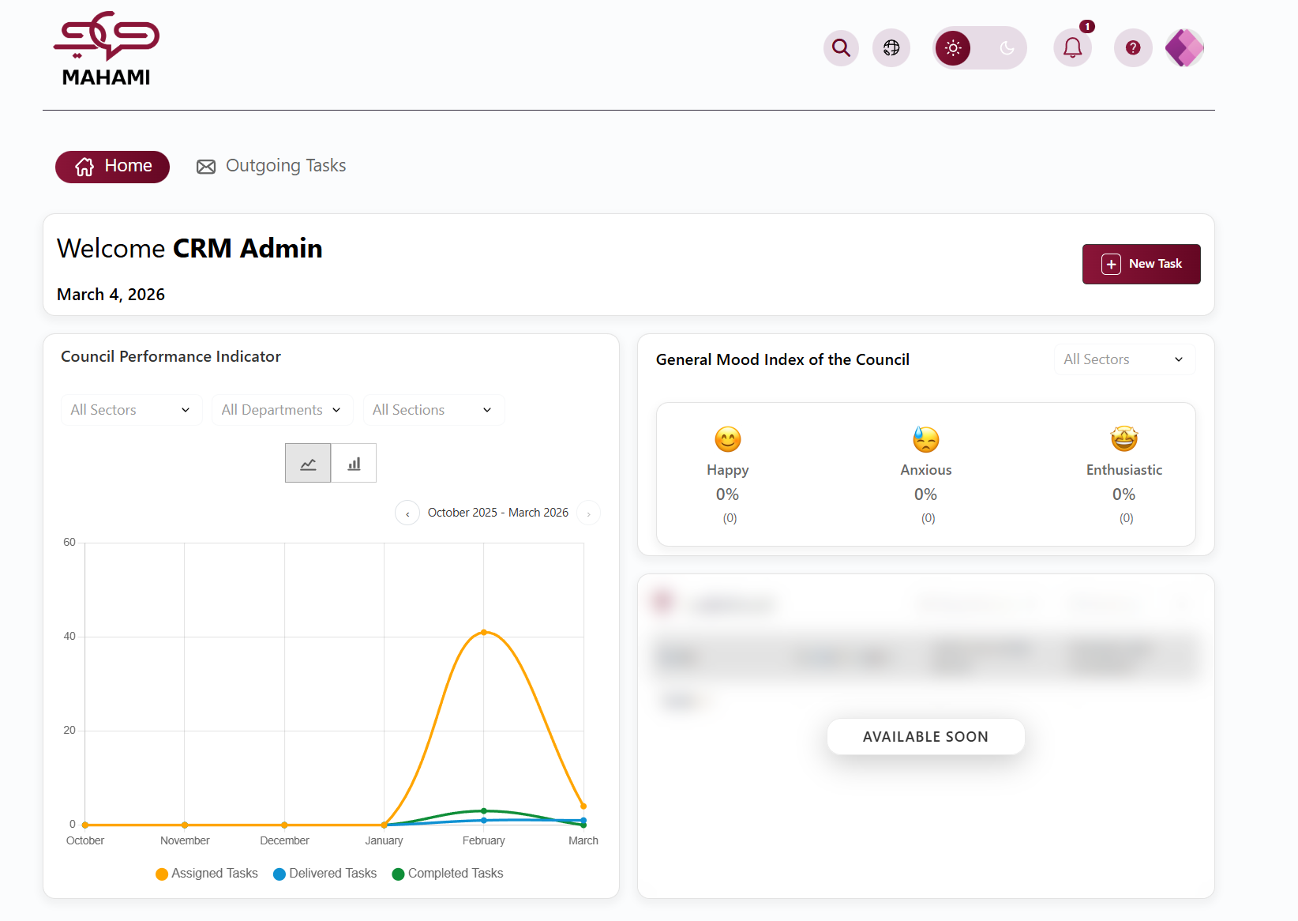

Language Selection
Choose your preferred interface language, providing a personalized and comfortable user experience that suits your personal needs.
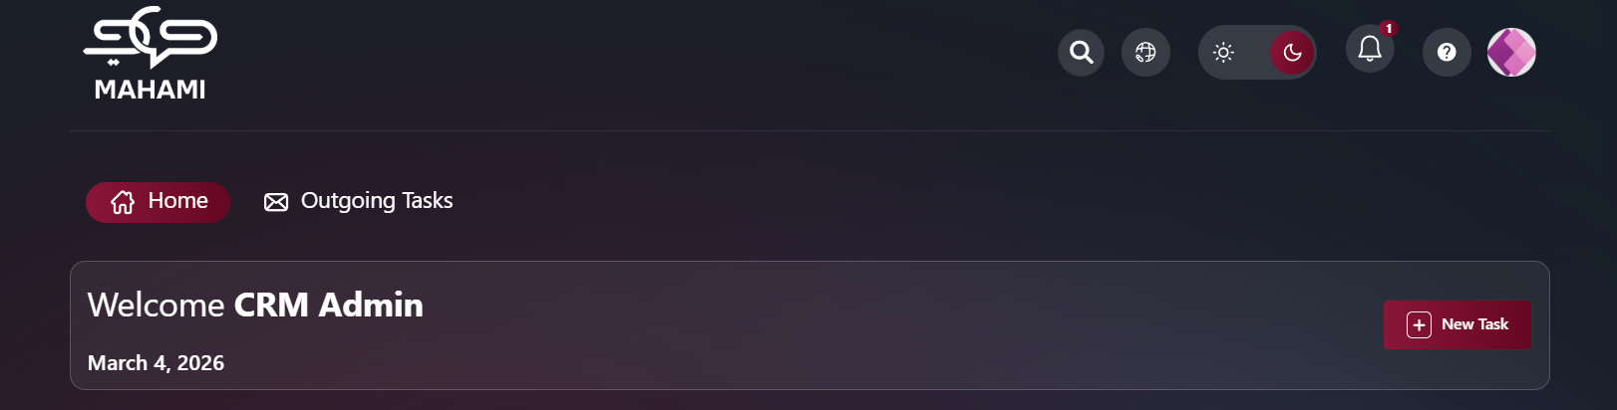

Global Search Feature
The search function helps you quickly find any task, document, or information.
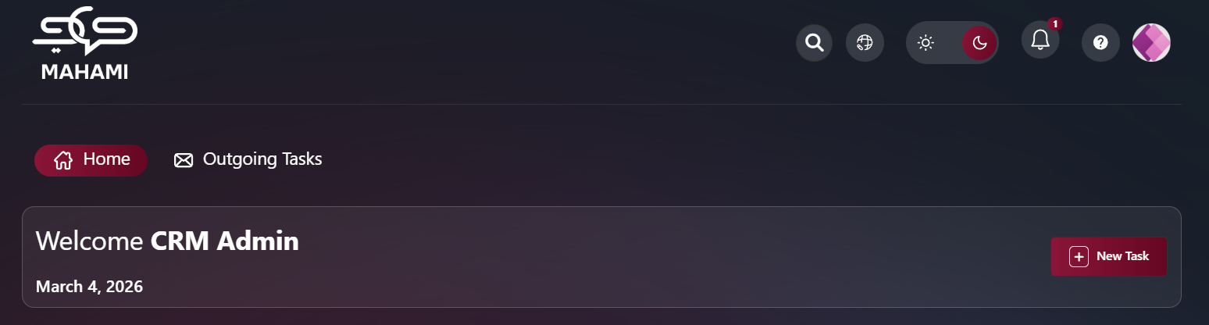
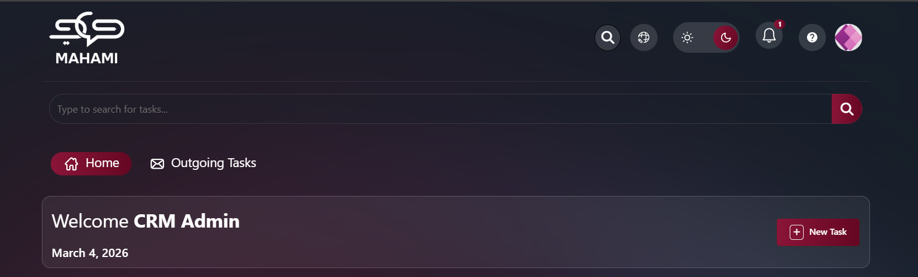

Welcome Text Message
Personalized Greeting:
- Displays at the top of the home page
- Shows personalized welcome message with your full name
- Displays current date below the greeting
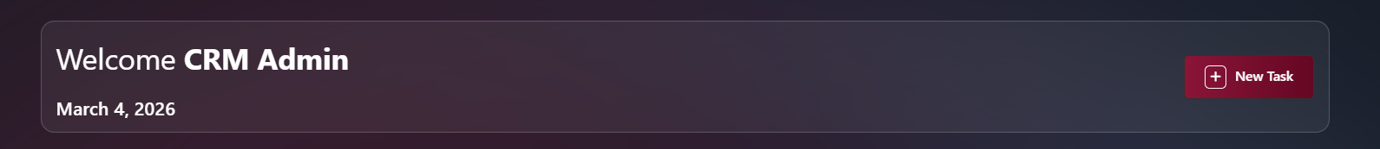

New Task
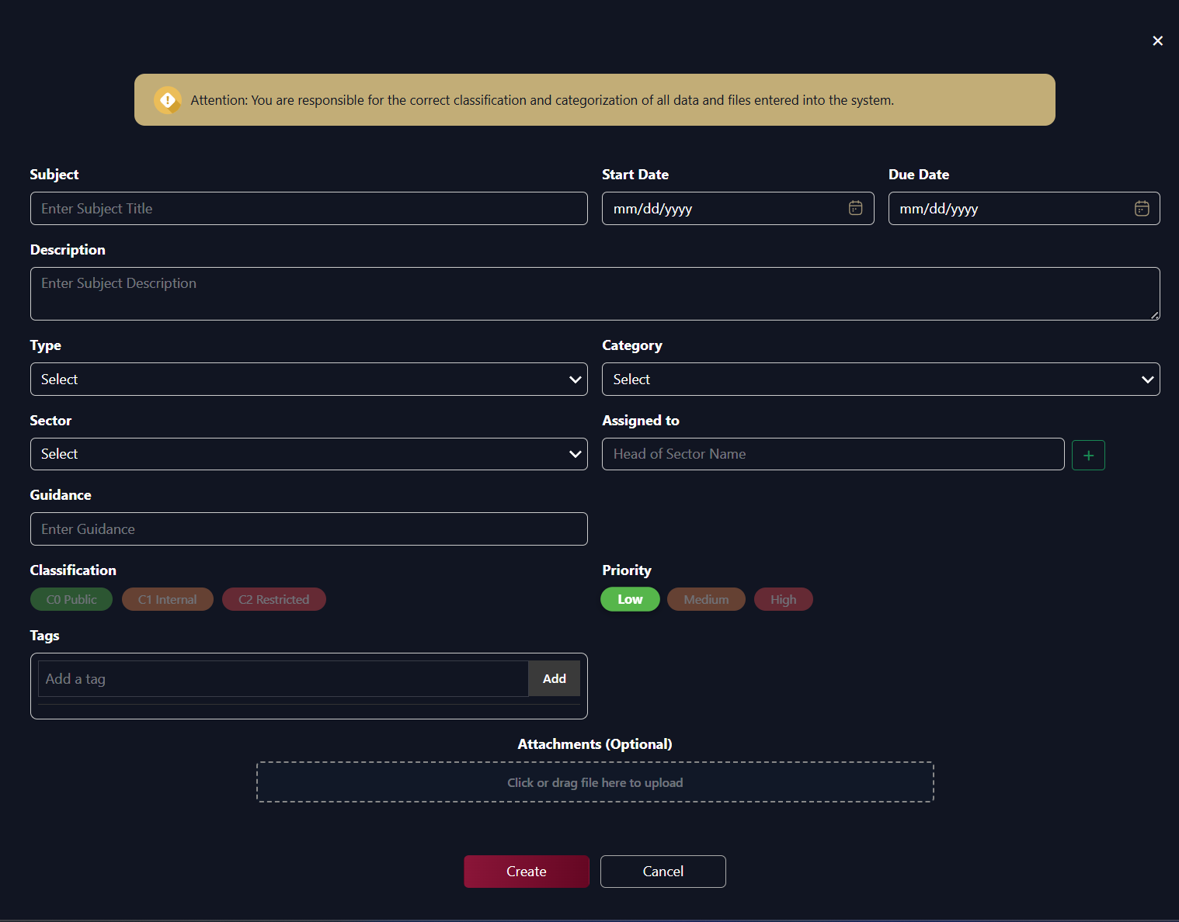
Data Classification Notice:
- Yellow banner at top: "Attention: You are responsible for the correct classification and categorization of all data and files entered into the system."
Fill in Task Information:
Required Fields (marked with red border when empty):
- Subject: * Task title
- Priority: * High, Medium, Low
- Due Date: * Delivery deadline
- Assigned to: * Select person(s) to execute the task
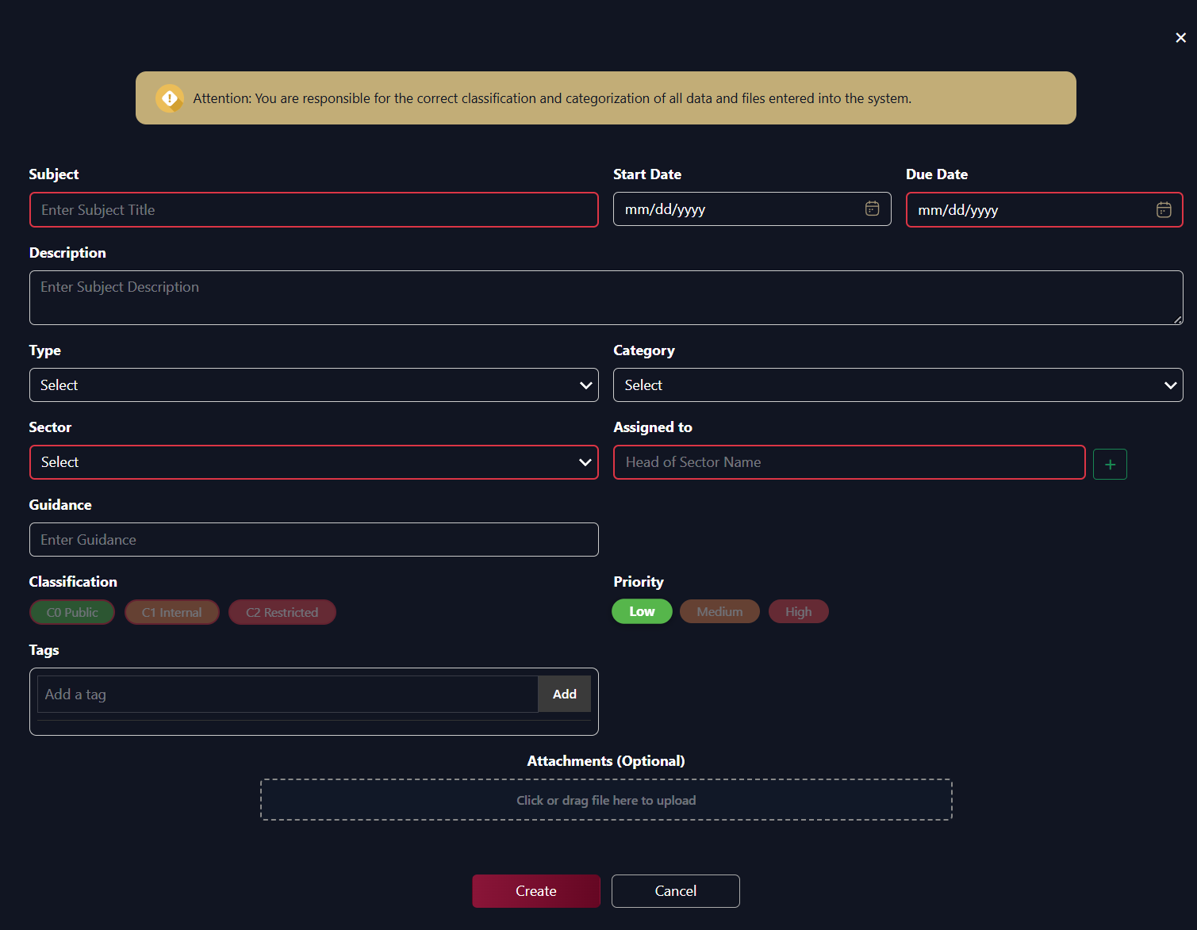
Optional Fields:
- Start Date: Planned date to start work (format: mm/dd/yyyy)
- Description: Task details and explanation
- Type: Select from dropdown
- Category: Select from dropdown
- Guidance: Add guidance and notes for the assignee
- Management brief: Enter management report details
- Tags: Add classification tags for the task
Multi-Assignment Feature:
- Click the + (plus icon) next to "Assigned to" field to add multiple assignees
- Add additional Department and Assigned to fields as needed
- Click - (minus icon) to remove an assignment row
- Each assignee receives individual notification
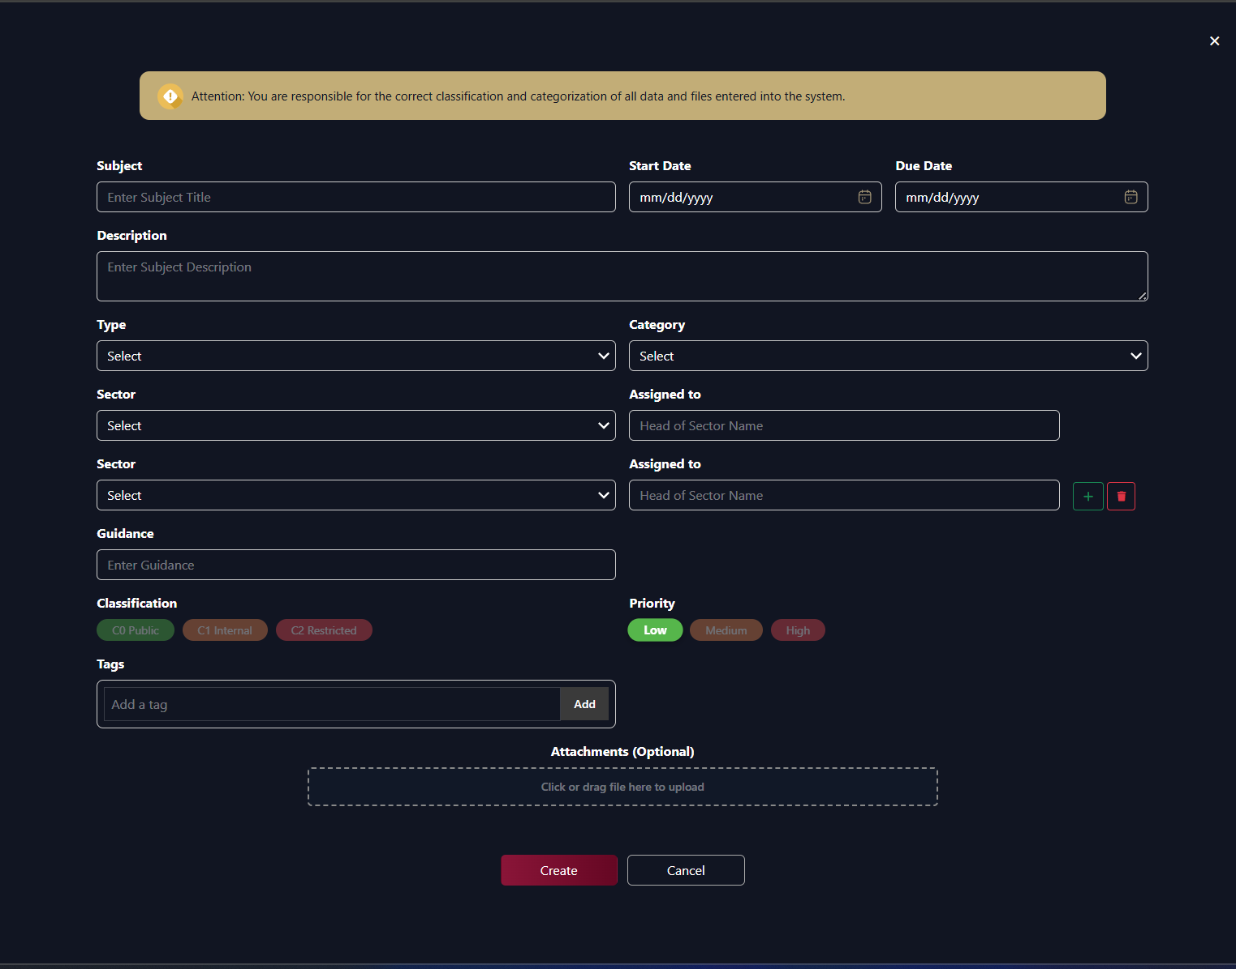
Classification Options:
- C0 Public (Green)
- C1 Internal (Orange)
- C2 Restricted (Red)
Priority Options:
- Low (Green)
- Medium (Orange)
- High (Red)
Attachments:
- Click or drag file to upload area
- Optional field
- Upload related files and documents
Actions:
- Save: To save the task as draft
- Cancel: To exit without saving
Validation:
- Error message appears in top right if required fields are missing: "Please fill the required fields"
- Due Date must be after Start Date

Council Performance Indicator
- The Council Performance Indicator shows how many tasks were assigned, delivered, and completed over time, so you can see workload and completion trends.
Chart overview
- Chart type: Line chart (performance view).
- X-axis: Months in the selected period (e.g. September, October, November, December, January, February). The period is always 6 months.
- Y-axis: Task count. The scale is set automatically from the data.
- Time navigation: Above the chart, a label shows the current 6-month range (e.g. “September 2024 – February 2025”). Use ‹ to move the window 6 months back in time and › to move it 6 months forward (the › button is disabled when the window already includes the current month).
- Filters (above the chart): Sector, Department, and Section. Choose “All” or a specific value; the chart and counts update to match the selected scope (based on task owner’s sector/department/section).
- Hover: Hovering a point shows a tooltip with the month and year (e.g. “December 2024”) and the counts for that month.
Performance metrics (three lines)
- Assigned Tasks (orange line)
- Total number of tasks assigned in that month (all assigned tasks created in the month).
- Delivered Tasks (blue line)
- Tasks delivered / pending approval (status: Delivered) in that month.
- Completed Tasks (green line)
- Tasks completed (status: Completed) in that month.
Second view: Sector Heads chart
- Use the toggle next to the chart: the line icon is the Council Performance Indicator; the bar icon is “Sector Heads Tasks.”
- The Sector Heads view shows a vertical bar chart by sector with the same three metrics (Assigned, Delivered, Completed) per sector. Filters are hidden in this view; it always shows all sectors.
Purpose
- See trends in assigned vs delivered vs completed tasks over 6-month windows.
- Compare different time periods by moving back/forward in 6-month steps.
- Narrow by Sector, Department, or Section to analyze a specific part of the council.
- Use the Sector Heads chart to compare performance across sectors.
How to use
- Use Sector, Department, and Section to focus on a specific area (or leave “All” for the whole council).
- Use ‹ and › to move to earlier or later 6-month periods.
- Hover over points to see the exact month, year, and counts.
- Switch to the bar chart view to compare sectors.
- Review the chart regularly to track trends and support planning and resource decisions.
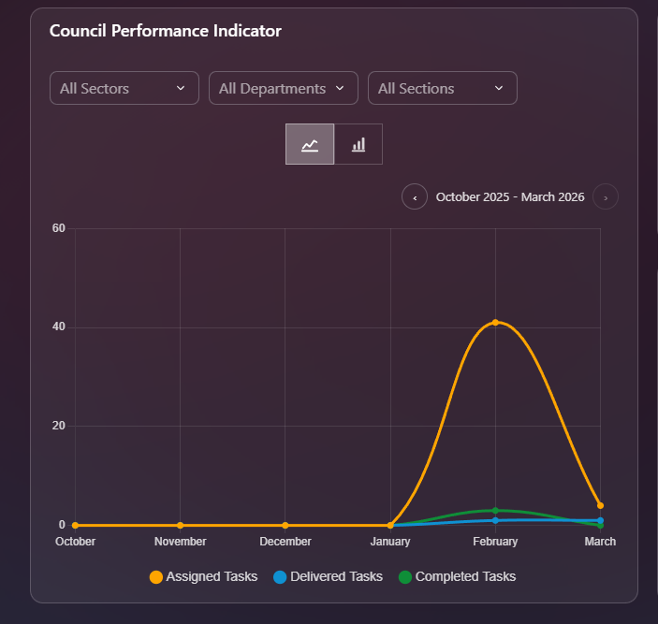

Mood Indicator
The General Mood Index provides real-time insights into the collective emotional state and morale of the organization, helping leadership understand employee engagement and well-being.
Overview: Displays the mood distribution across the entire organization with percentage breakdowns for each mood category.
Filter Options:
- All Sectors dropdown: View mood data by specific sector or entire organization
- Real-time updates as employees submit their mood indicators
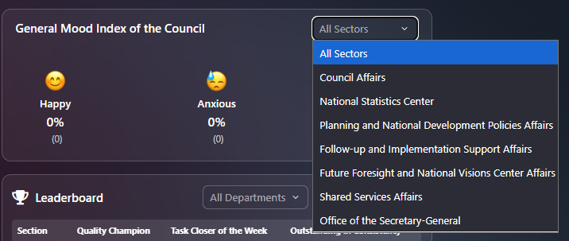
Three Mood Categories:
Happy 😊
- Percentage of employees feeling positive and content
- Example: "0%"
- Count shown in parentheses: "(0)"
- Yellow/gold emoji indicator
Anxious 😰
- Percentage of employees feeling stressed or worried
- Example: "0%"
- Count shown in parentheses: "(0)"
- Concerned face emoji indicator
Enthusiastic 🤩
- Percentage of employees feeling highly motivated and energized
- Example: "0%"
- Count shown in parentheses: "(0)"
- Star-struck emoji indicator
Display Format:
- Large emoji for each mood category
- Percentage displayed prominently below emoji
- Actual count of employees in parentheses
- Clean, easy-to-read layout
Purpose:
- Leadership Awareness: Understand organizational morale in real-time
- Early Warning System: Identify potential stress or engagement issues
- Sector Comparison: Compare mood across different sectors
- Trend Monitoring: Track morale changes over time
- Intervention Planning: Take proactive action when needed
- Culture Assessment: Evaluate organizational culture health
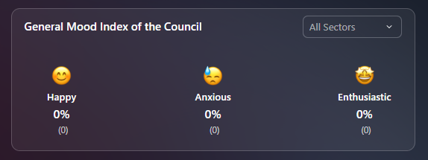

Leaderboard
The Leaderboard provides comprehensive recognition of top performers across the entire organization, visible only to President/Secretary General level.
Filter Options:
- All Departments dropdown: Filter by specific department or view organization-wide
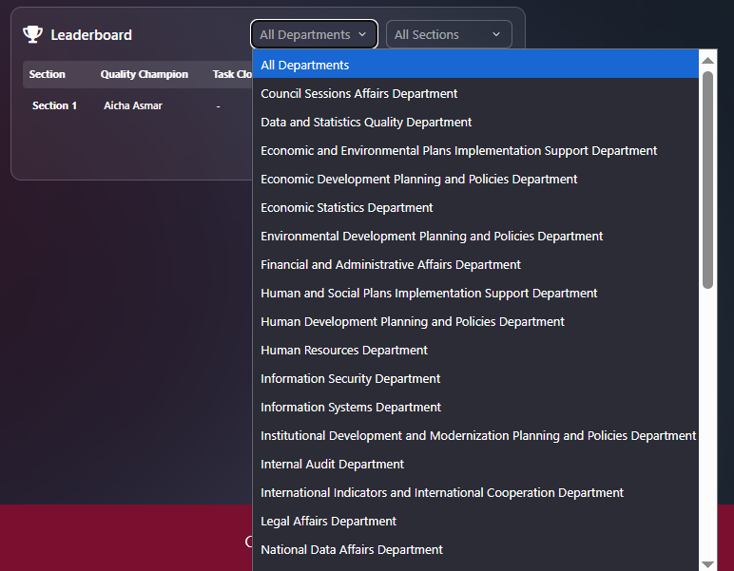
- All Sections dropdown: Filter by specific section within departments
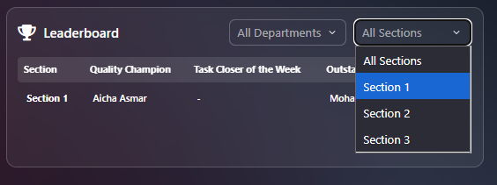
Leaderboard Table Structure:
Column Headers:
- Section
  - Organizational unit or team identifier
  - Example: "Section 1"
- Quality Champion
  - Employee with highest quality rating of completed tasks
  - Name displayed (Example: "Aicha Asmar")
  - Shows "-" if no winner for that section
- Task Closer of the Week
  - Employee with highest number of tasks closed during the week
  - Name displayed or "-" if none
- Outstanding in Consistency
  - Employee with best continuous achievement streak
  - Name displayed (Example: "Mohammed Ali")
Performance Categories Explained:
Quality Champion 🏆
- Criteria: Highest average quality rating on completed tasks
- Measurement: Based on supervisor ratings and evaluations
- Recognition: Excellence in work output and attention to detail
- Purpose: Encourage high-quality deliverables
Task Closer of the Week 🏆
- Criteria: Highest number of tasks successfully completed
- Measurement: Count of tasks moved to "Completed" status
- Recognition: Productivity and efficiency
- Purpose: Motivate timely task completion
Outstanding in Consistency 🏆
- Criteria: Best continuous achievement streak
- Measurement: Consecutive weeks/days of meeting targets
- Recognition: Sustained high performance
- Purpose: Reward reliability and dedication
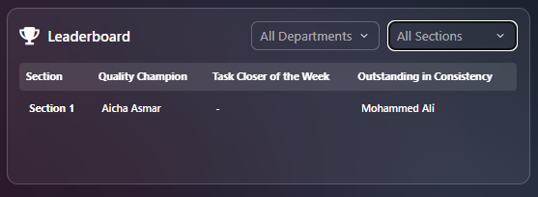

Outgoing Tasks
Click on Outgoing Tasks from the top navigation bar to view all tasks you have assigned to others.
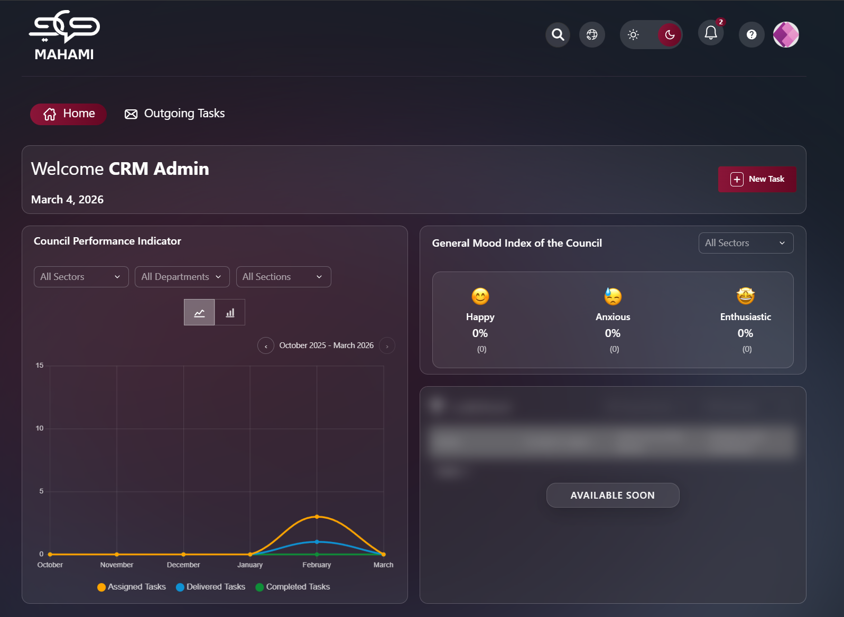
Page Overview
The Outgoing Tasks page displays all tasks you have created and assigned to team members in a table format, allowing you to track their progress and manage assignments.
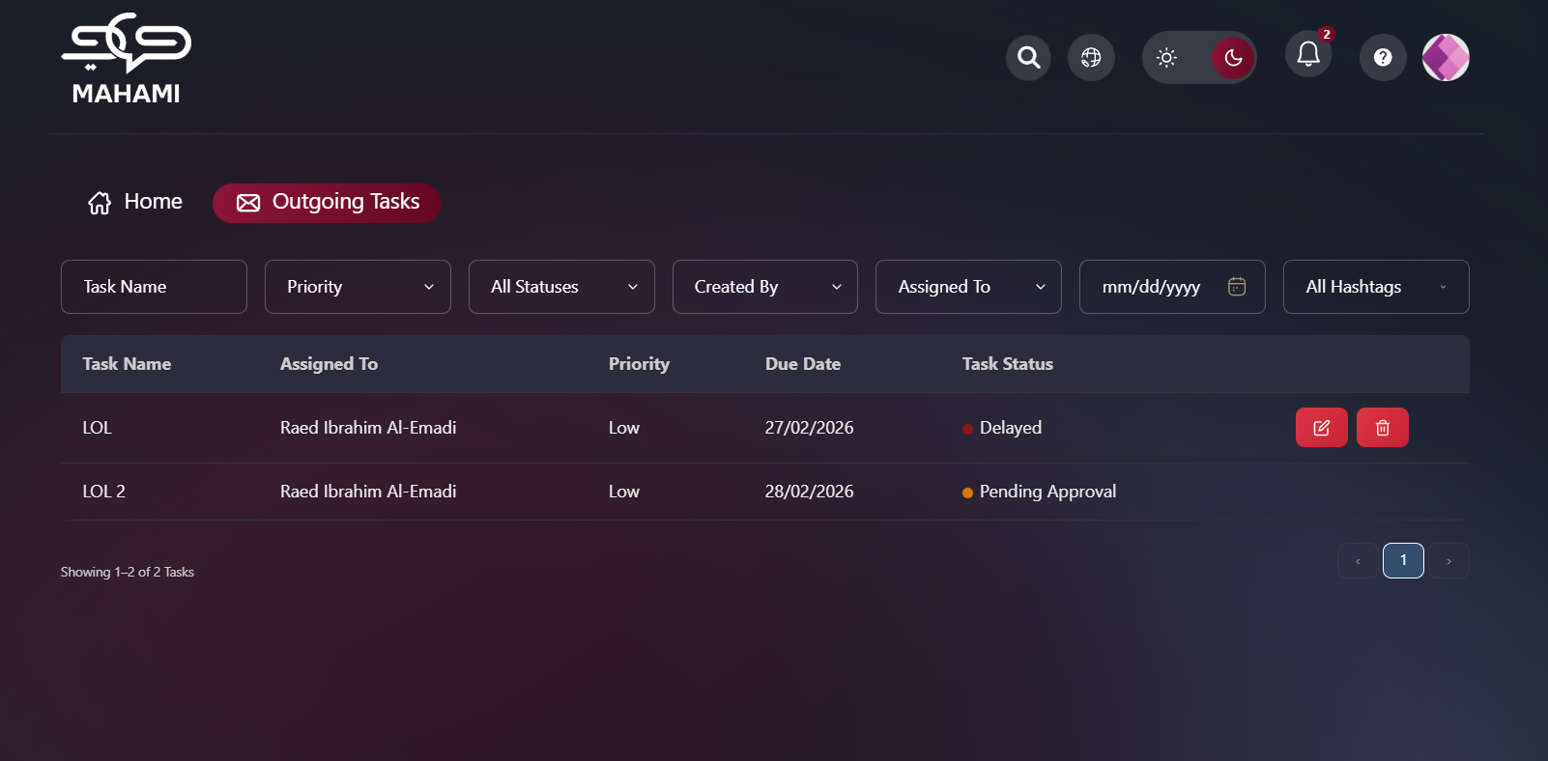
Filter and Search Options
Date Filter:
- Click on date field (mm/dd/yyyy format)
- Opens calendar popup
- Select specific date or date range
- Shows current month (October 2025)
- Navigation arrows to move between months
- Clear button: Remove date filter
- Today button: Jump to current date
- Current date highlighted in blue

Status Filter:
- All Statuses dropdown: Shows all task statuses by default
- Filter options:
  - All Statuses (highlighted in blue when selected)
  - Not Started
  - In Progress
  - Pending Approval
  - Completed
  - Delayed
  - Pending Delegation
Task Name:
- Allows searching for a task by entering part or all of the task title.
The system performs a partial match search, meaning you can type a keyword instead of the full task name.
Priority:
- Filters tasks based on their assigned priority level (e.g., High, Medium, Low).
This helps focus on urgent tasks or review lower-priority items when needed.

Created By:
- Displays tasks based on the user who originally created them.
This is useful when tracking tasks initiated by a specific manager or employee.
Assigned To:
- Filters tasks according to the current assignee.
This allows managers to quickly view tasks assigned to a specific department head, section head, or employee.
All Hashtags:
- Filters tasks based on associated hashtags or tags.
This enables categorization and quick grouping of related tasks (e.g., project-based tags, operational categories, or special initiatives).

Table Columns
Task Name:
- Subject/title of the assigned task
- Clickable to view task details
Assigned To:
- Name of person responsible for the task
Priority:
- High, Medium, or Low priority level
- Displayed as text
Due Date:
- Deadline for task completion
- Format: dd/mm/yyyy
Task Status:
- Status with color-coded indicator:
  - Blue dot: In Progress
  - Gray dot: Not Started
  - Other status indicators as applicable
Actions:
- Red trash icon to delete task (on right side of each row)
- Red Pencil icon to edit the task (on the right side of each row)
Note: Only task creators can edit or delete tasks except for secretaries, they are able edit and delete tasks that was created by them on behalf of their managers. Pending Approval (Delivered) and Completed tasks cannot be deleted nor edited
