
Task Management System



User Manual

Prepared by

Table of Contents
1. Version History 3
2. Reviewers 3
3. Approvers 3
4. Introduction 4
5. Definition of the System 4
6. System Functionality 4
7. Workflow and Available Actions for Employee 4
7.1 Receiving Tasks from Section Head 4
7.2 Available Actions for Employee 5
7.3 Handling Delegated Tasks 9
7.4 Types of Tasks in the System 9
7.5 Task States and Management 9
7.6 Support Features for Employee 9
7.7 Tips for Efficient System Use 10
8. Mahami App 10
8.1 Login 10
8.1.1 Access the System 10
8.2 Home 12
8.3 All Tasks 16
8.3.2 Mood Indicator 18

Version History
Date | Author | Version | Change Reference
September 29, 2025 | Abdullah Shehata | V1.0 | Initial Version
October 16, 2025 | Sirine Hammad | V1.1 | Second Version

Reviewers
Name | Position | Version Approve | Date
Hussein Chamseddine | Project Manager | V1.0

Approvers
Name | Position | Version Approve | Date

Employee Guide

Introduction
This system aims to provide a comprehensive and integrated solution for task management by facilitating and simplifying all stages related to creating, modifying, tracking, and evaluating task results. The system also focuses on enhancing workflow efficiency and ensuring tasks are executed in an organized and effective manner.
One of the primary objectives of this project is to address current challenges and problems users face in traditional systems, whether in terms of slow performance, poor coordination between teams, or difficulty accessing task-related information.
Additionally, the system seeks to improve user experience through an easy-to-use interface, providing accurate analytical reports, and smart notifications and alerts that help track work progress and ensure completion within the specified time with the ability to reassign and delegate tasks.

Definition of the System
Authorized employees can access the system through the following link:
Mahami
Note: The company email username and password are used to log into the system.

System Functionality
The system provides a set of tools for efficient task management. Here are its main functions:
- Create Tasks: You can create personal tasks or assign them to others
- Track Tasks: The system provides dedicated pages for tracking outgoing tasks or personal tasks
- Team Management: You can monitor your team's performance through a comprehensive dashboard
- Advanced Details: The system supports adding subtasks, attaching files, and adding comments
- Notifications: The system sends instant notifications about new tasks and updates

Workflow and Available Actions for Employee
This section defines the workflow and available actions for the Head of Department in the task management system, from receiving tasks from the Sector Head to completing or reassigning them.

Receiving Tasks from Section Head or Head of Department or Sector Head
When a task is assigned from the Section Head or Head of Department or Sector Head to the Employee:
- The employee receives an instant notification of the new task
- The task appears in the "All Tasks" list with status "Not Started Yet"
- Task details can be accessed by clicking on it
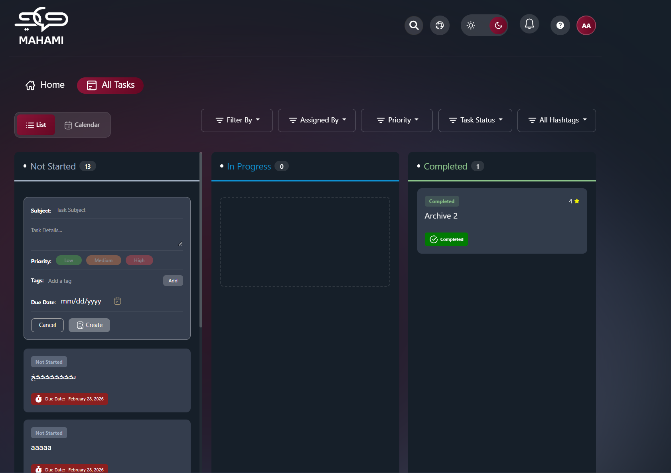

Available Actions for Employee
Once the task is received, the employee has two main options:
- Executing the Task Personally:
Starting Work on the Task:
- Drag and drop the task into the "In Progress" column
- Task status automatically updates to "In Progress"
- Add comments and notes while working
- Upload relevant attachments and files
Completing the Task:
- Move the task to the "Delivered" column after completion
- Add a final report or achievement summary
- Notify the Section Head for review

Section Head Review: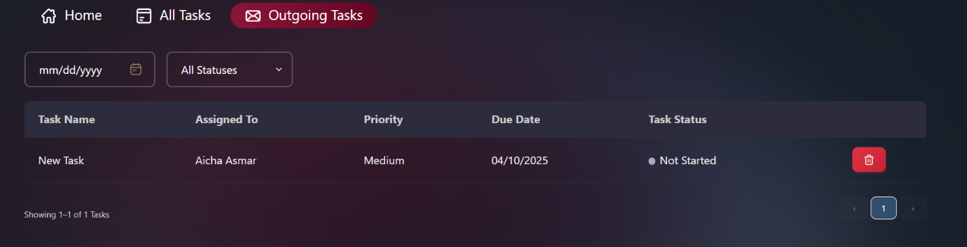
- Approval: The task becomes finally completed
- Rejection: The task returns with modification notes
- Upon approval, the completed task is evaluated
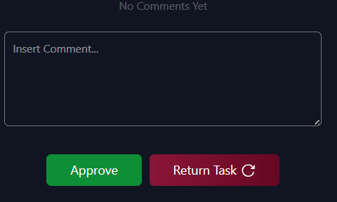
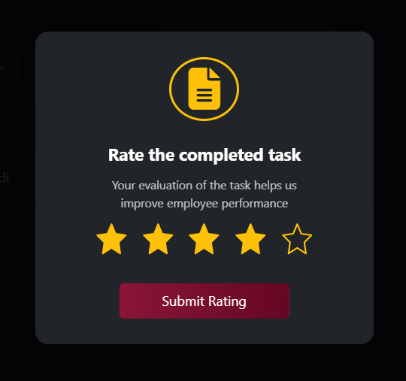
- Requesting Task Delegation:
Conditions for Delegation Request:
- Having an acceptable justification for delegation (work pressure, schedule conflict, lack of expertise or others)
- Identifying the proposed employee for delegation
- Obtaining prior approval from manager
Steps for Requesting Delegation:
- Click on the "Request Delegation" option
- Select the reason for the delegation request
- Suggest the alternative employee
- Send the request to the Manager for approval
Result of Delegation Request:
- Approval: Transfer the task to the delegated employee
- Rejection: Return the task to the original employee

Click on the received task then choose Delegate as shown below:
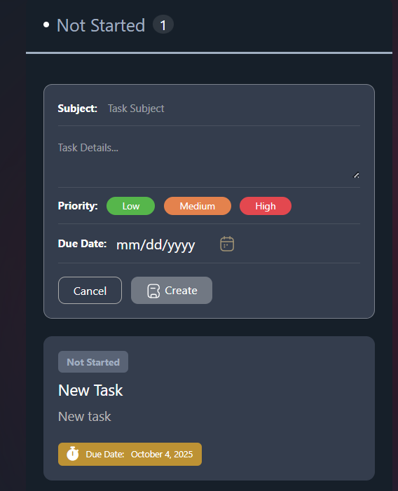

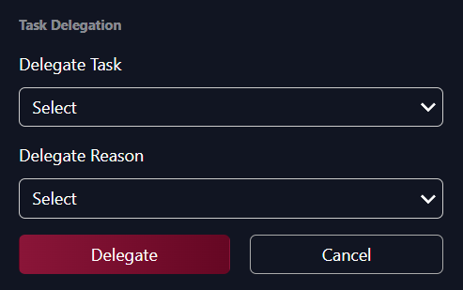

Handling Delegated Tasks
When a task is delegated to the employee from another employee:
- Receives a notification of the delegated task
- Review task details and requirements
- Execute the task following the same normal execution steps
- Communicate with the original employee when clarification is needed

Types of Tasks in the System
- Personal Tasks:
- Self-assigned tasks
- Appear in the "All Tasks" list
- Main Tasks:
- Tasks assigned by managers
- Delegated Tasks:
- Tasks received from other employees with Manager approval
- Carry the same priority and deadline as the original task
- Subtasks:
- Parts of larger tasks
- May be linked to other main tasks

Task States and Management
Basic Task States:
- Not Started Yet:
- Newly assigned tasks
- Waiting to start execution
- In Progress:
- Tasks currently being worked on
- Continuous update of progress and notes
- Completed:
- The task has been successfully completed, formally approved, and evaluated.
- Overdue:
- Tasks that missed the deadline
- Require urgent action
- Pending Approval:
- Completed tasks awaiting review
- Requires approval from manager
- Pending Delegation Approval:
- An employee requested to delegate their task to someone else
- Approval is required from either the Head of Department or the Head of Section or Head of Sector, based on the task assigner.

Support Features for Employee
- Smart Notifications:
- New task notifications
- Deadline alerts
- Delegation request status updates
- Self-Monitoring:
- Track personal work progress
- Individual completion statistics
- Completed tasks history
- Communication:
- Comments on tasks
- Request clarifications from Section Head

Tips for Efficient System Use
- When Receiving a New Task:
- Read task details carefully
- Understand requirements and expectations
- Request clarification when unclear
- Estimate the time required for execution
- While Executing Tasks:
- Update task status regularly
- Add comments explaining progress
- Upload attachments progressively
- Communicate early when facing difficulties
- When Requesting Delegation:
- Suggest a suitable alternative
- Ensure the delegated person's ability to execute
- Follow up with the delegated person when needed
- When Completing Tasks:
- Review the completed work
- Ensure all requirements are fulfilled
- Add a clear achievement summary
- Deliver work on time
- Mahami App

  - Login
    - Access the System
      - Accessing the System URL
Click On The Provided link: Mahami
      - Login Credentials
Use your email and password (same as Outlook credentials).
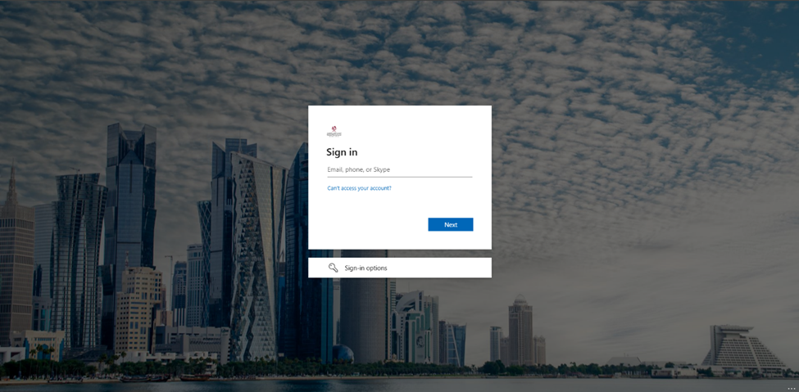

Home
After logging in, you are directed to the Home page.
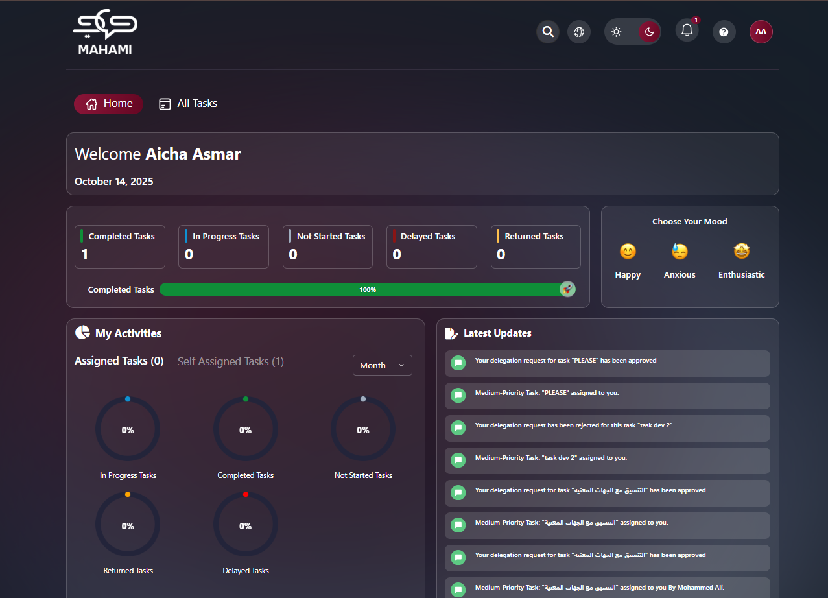

Profile Page
The profile page allows users to customize their account by uploading a personal photo, providing a personalized and comfortable user experience that suits their personal needs.
Default Avatar:
- When no photo is uploaded or after deletion, the system displays your initials
- Format: First letter of First Name + First letter of Last Name
- Unique color assigned automatically for visual distinction
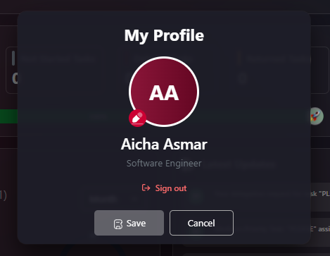
Uploading a Profile Picture:
- Click on profile icon → "My Profile"
- Click edit icon on avatar
- Select image file (JPG, PNG - Max 5MB)
- Crop if needed
- Click "Save"
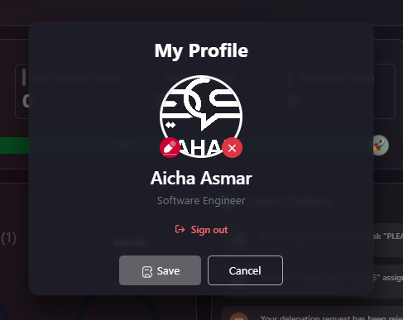
Deleting Your Profile Picture:
- Go to "My Profile"
- Hover over current picture
- Click delete icon (trash can/camera with X)
- Confirm deletion
- Click "Save"
- Profile reverts to initials avatar
Additional Profile Information:
- Full name displayed
- Department/Position (shows "N/A" if not configured)
- Sign Out button at bottom
- Save/Cancel buttons for changes

Help & Support
The Help & Support feature allows you to quickly submit questions, report issues, or request assistance directly to the support team.
Form Fields:
- Name: * Auto-filled from your profile
- Email Address: * Auto-filled with your company email
- Subject: * Brief description of your issue
- Message: * Detailed explanation of the problem
Actions:
- Send Message: Submit support request
- Cancel: Close without sending
Response Time:
- 24-48 business hours via email
Common Issues:
- Technical problems
- Feature questions
- Access issues
- Training requests
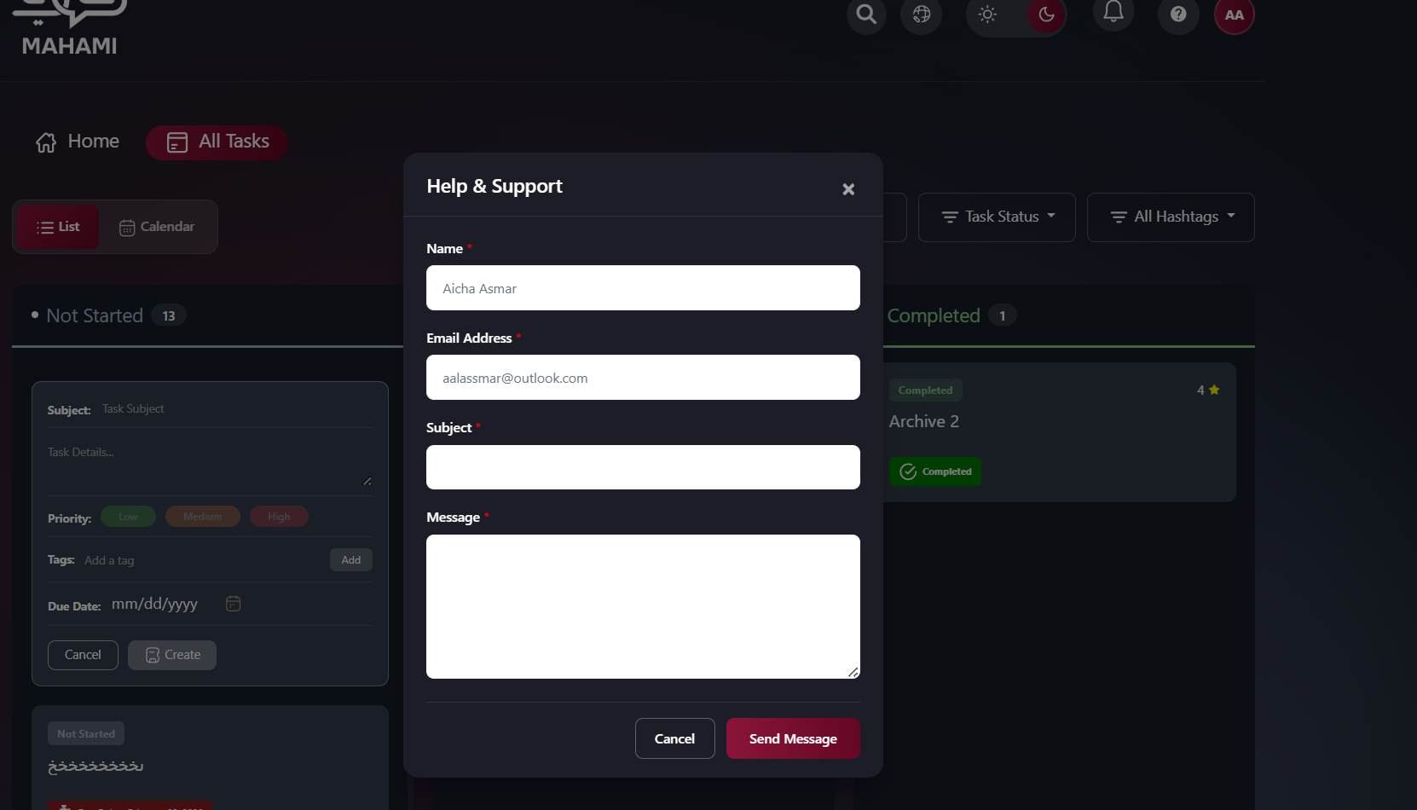

Notifications
From the top right, click on Notifications to display the notifications list.
Notification Status Indicators:
- Green dot: New/unread notification
- Gray: Read notification after clicking or marking as read
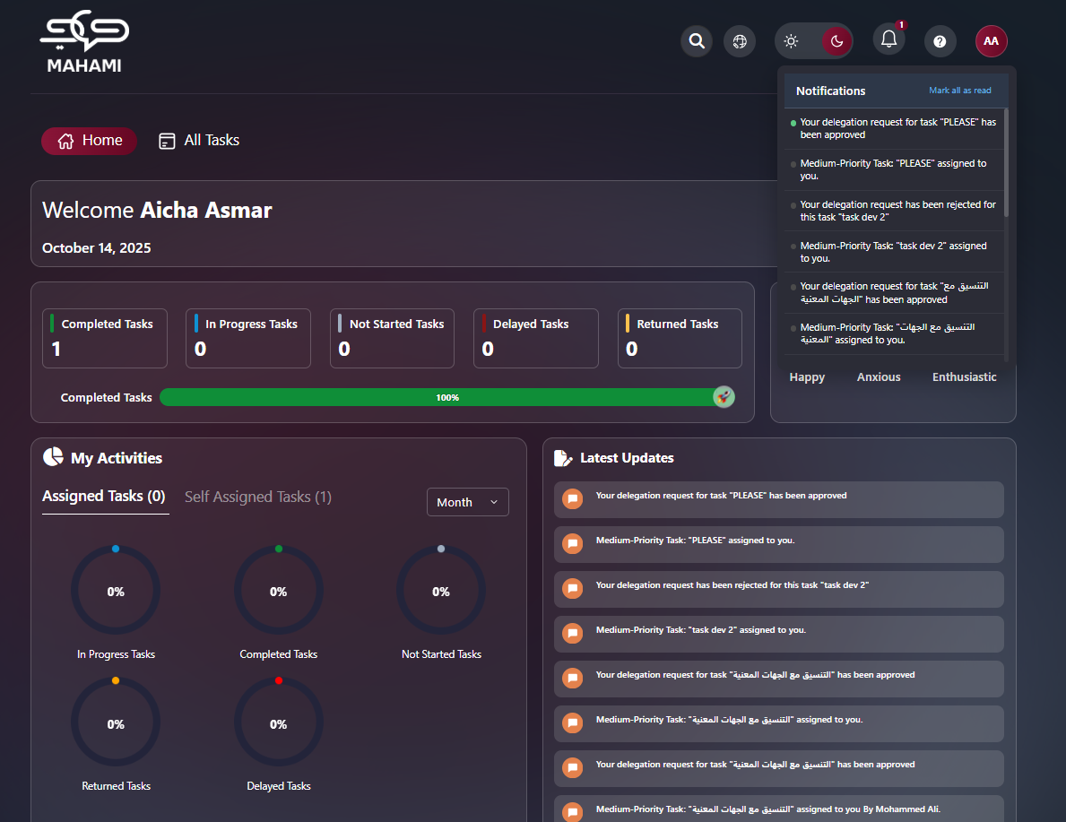
Clickable Notifications:
- Click on any notification to view the related task directly
- Automatically marks notification as read (turns gray)
- Takes you to the task details page
Managing Notifications:
- Mark All as Read: Click button at top to mark all notifications as read
- All green indicators turn gray
- Clears notification count badge
Latest Updates Section:
- Displays of recent notifications in chronological order
- Icon color based on task priority (green for low, orange for medium, red for high)
- Most recent notifications appear at the top
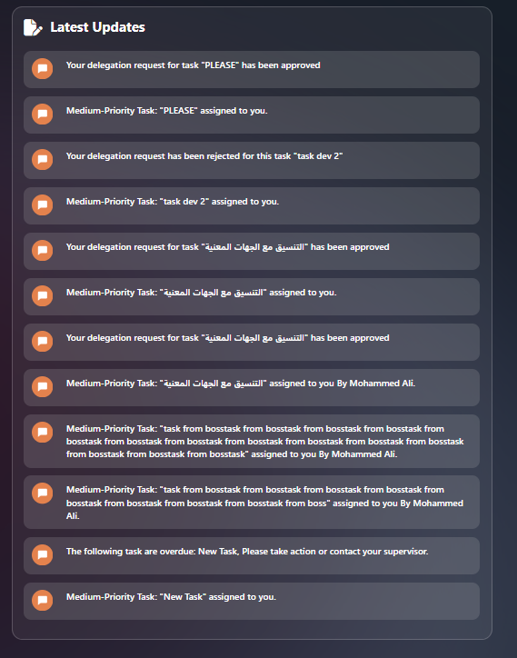
Notification Types:
- New task assigned
- Deadline approaching
- Task completed
- Approval required
- Delegation requests

Lighting Mode
Toggle between day and night mode using the button at the top left.

Night mode

Light Mode
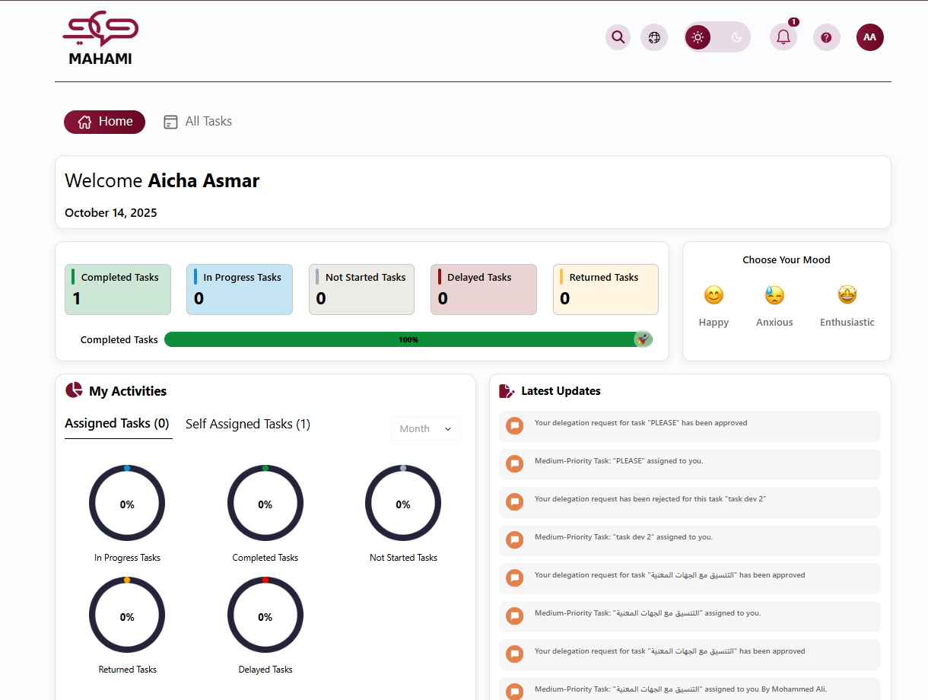

Language Selection
Choose your preferred interface language, providing a personalized and comfortable user experience that suits your personal needs.

Global Search Feature
The search function helps you quickly find any task, document, or information.
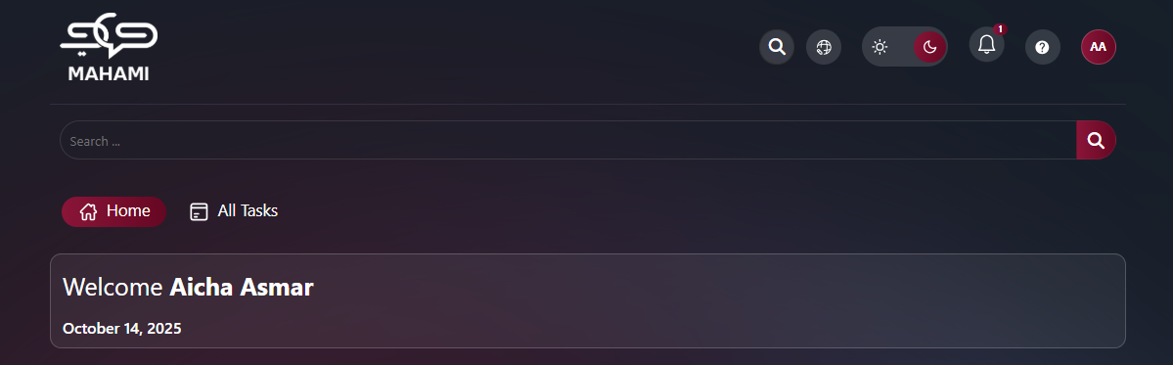

Welcome Text Message
Personalized Greeting:
- Displays at the top of the home page
- Shows personalized welcome message with your full name
- Displays current date below the greeting
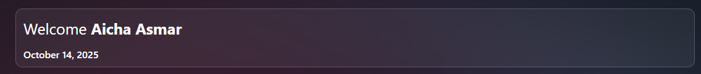

Task Dashboard Overview
The system automatically calculates and displays all your tasks across different categories on the dashboard.
Task Status Cards:
The dashboard displays five main task status cards with real-time counts:
- Completed Tasks (Green border)
  - Shows number of tasks you've finished
  - Includes both personal tasks and subtasks and assigned ones
- In Progress Tasks (Blue border)
  - Shows tasks currently being worked on
  - Tasks you've moved to "In Progress" status
- Not Started Tasks (Gray border)
  - Shows newly assigned tasks not yet begun
  - Tasks waiting for you to start
- Delayed Tasks (Red border)
  - Shows tasks past their due date
  - Only counts incomplete tasks with overdue dates
- Returned Tasks (Orange border)
  - Shows tasks rejected and sent back for revision
  - Tasks requiring modifications
Task Completion Progress Bar:
- Located below the status cards
- Shows percentage of completed tasks vs. total tasks
- Green progress bar with percentage displayed
- Checkmark icon indicates completion level
How Task Counts Are Calculated:
- Includes all personal tasks
- Includes all subtasks you're responsible for
- Updates in real-time as task statuses change
- Total count = Personal Tasks + Subtasks + Assigned Tasks
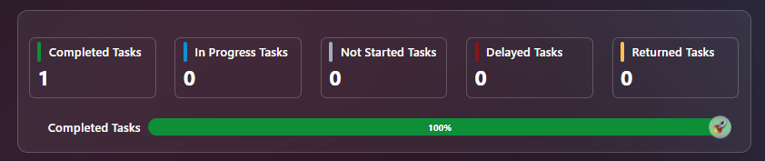

Mood Indicator
The mood indicator feature allows you to track and share your current work mood with the team.
Available Mood Options:
- Happy 😊 (Yellow border when selected)
- Anxious 😰 (Gray border when not selected)
- Enthusiastic 🤩 (Gray border when not selected)
How to Select Your Mood:
- Click on the desired mood emoji
- Selected mood is highlighted with yellow/golden border

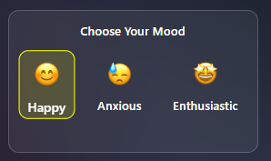

Dashboard
The dashboard provides a comprehensive and quick overview of all your tasks, statistics, and important updates, helping you track work progress and manage your workload effectively.
My Activities Section
Task Statistics Display:
Five circular progress indicators showing percentages:
- In Progress Tasks (Blue dot)
- Completed Tasks (Green dot)
- Not Started Tasks (Gray dot)
- Returned Tasks (Orange dot)
- Delayed Tasks (Red dot)
Task Count Tabs:
- Assigned Tasks (0): Tasks from others
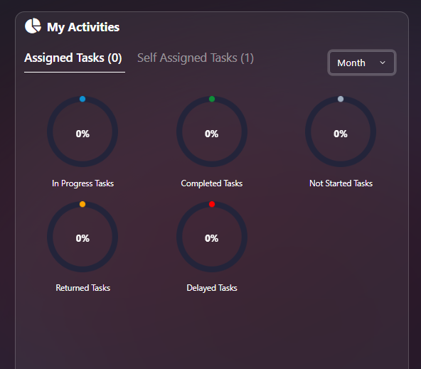
- Self-Assigned Tasks (7): Tasks you created
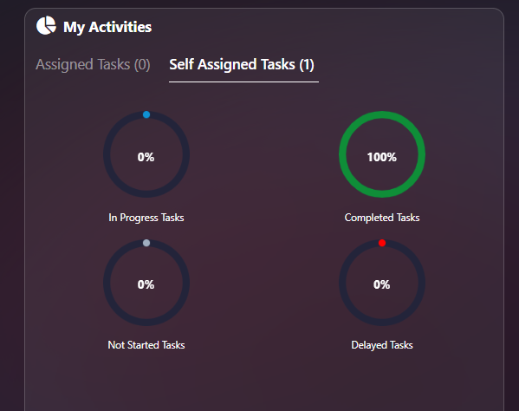
Time Filter:
- Month dropdown: Filter by specific month
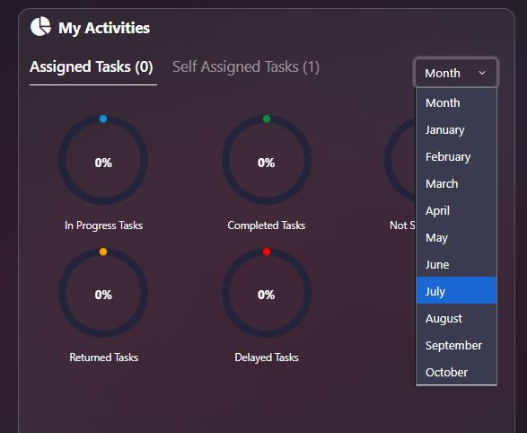

All Tasks
From the Home page, click on All Tasks to go to the "All Tasks" page and view tasks: "Not Started Yet - In Progress - Delivered".
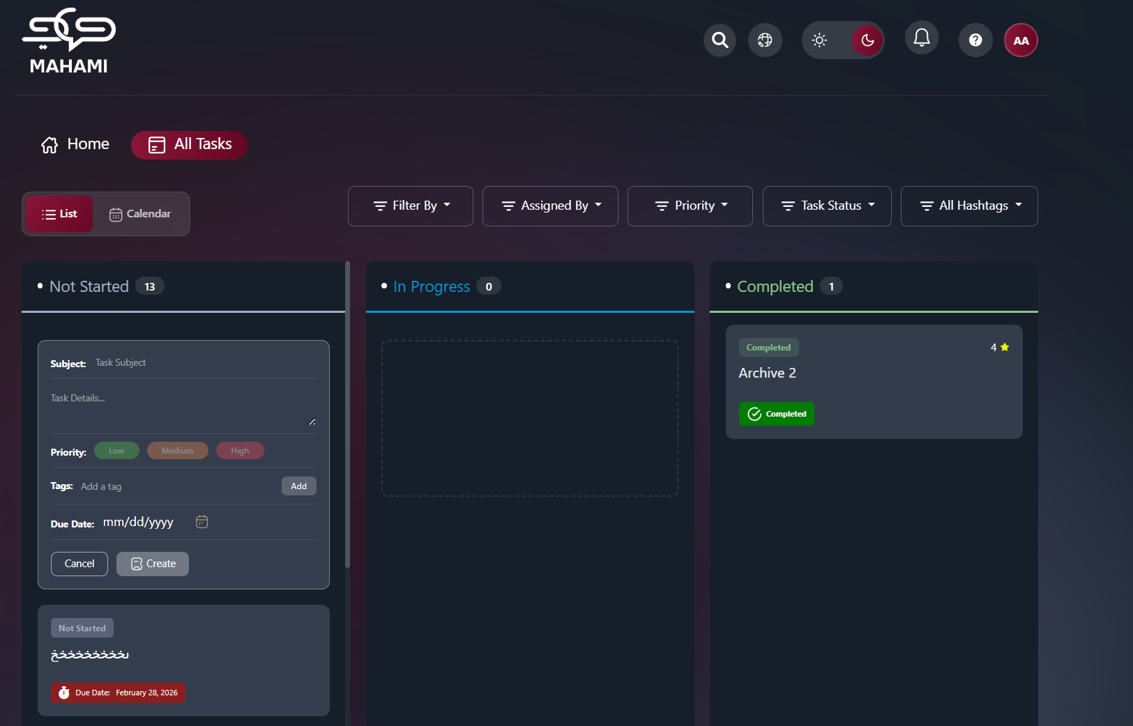
View Options
List View / Calendar Toggle:
- List button: View tasks in kanban board format
- Calendar button: View tasks in calendar format (highlighted when selected)
List View
Three Status Columns:
- Not Started
  - Tasks have not yet begun
  - Quick create form at top
  - Task cards with due date badges
- In Progress
  - Tasks currently being worked on
  - Drag and drop tasks here to start
- Completed
  - Finished tasks
  - Status badges: "Completed" or "Pending Approval"
  - Checkmark icon indicates completion
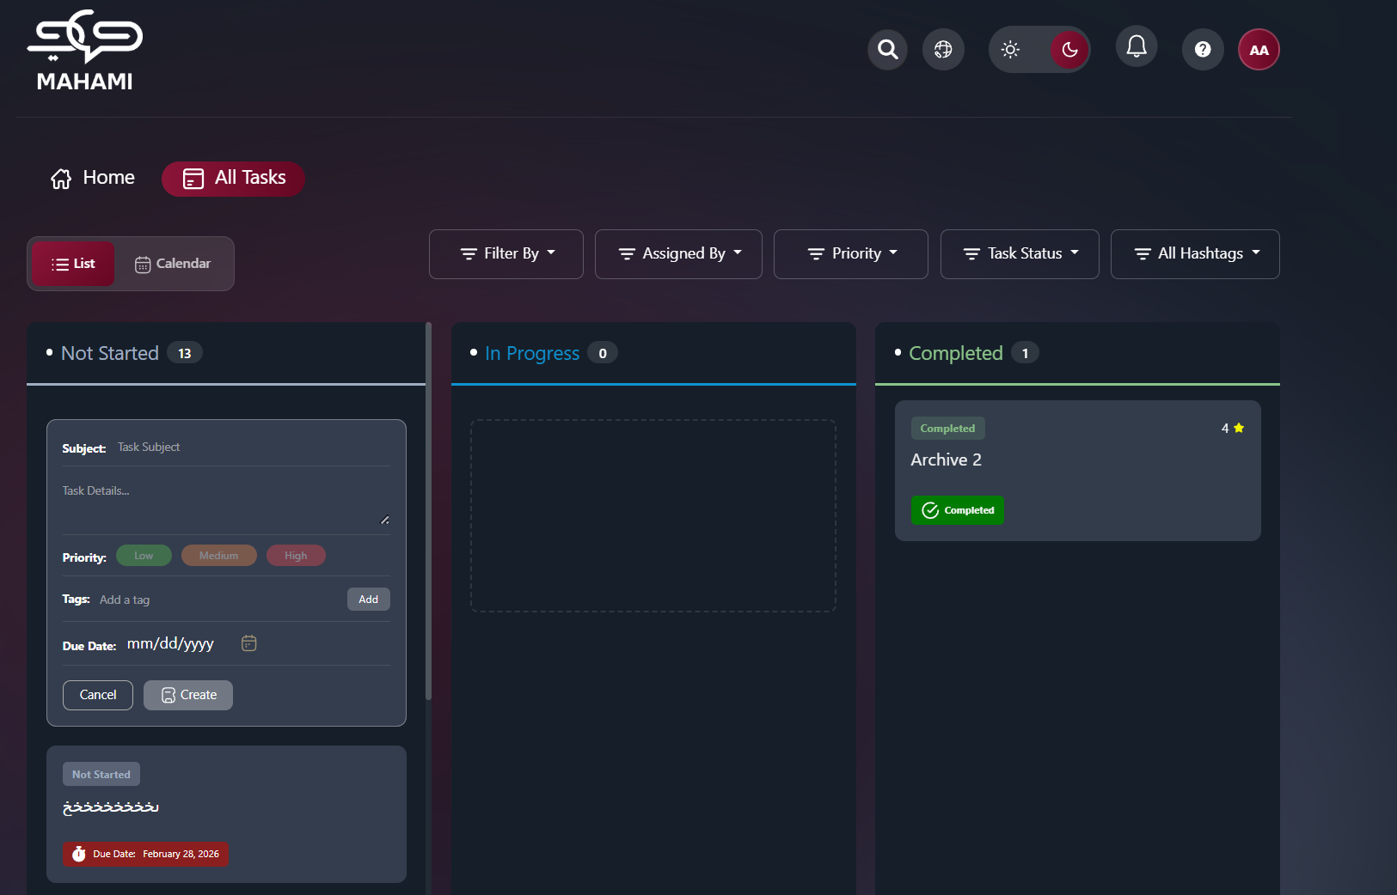
Filter By:
- All Tasks: View all tasks assigned to you
- Personal: Tasks you created for yourself
- Sub Tasks: Tasks that are part of a larger parent task
- Assigned Tasks: Tasks assigned to you by others

Assigned By: Filters tasks based on the user who originally assigned the task to you, allowing you to view tasks received from a specific manager
Priority filter: Narrows the task list by importance. Choose one or leave as “Priority” to see all.
- High
- Medium
- Low
Task status filter: Narrows the list by task state. Choose one option.
- All Status
- Not Started
- In Progress
- Pending Approval
- Completed
- Delayed
- Pending Delegation
All hashtags Filter: Narrows the list by one or more hashtags (tags). Default is “All Hashtags” (no filter). Open the control to pick hashtags; the list shows tasks that have at least one selected hashtag.
- Options are listed in the dropdown (e.g. #tag1, #tag2, …).
- You can select multiple hashtags.
- Use “Select all” / “Clear all” to quickly change the selection.
Quick Create Task:
- Subject: Enter task title (required)
- Task Details: Add description
- Priority: Low (green), Medium (orange), High (red)
- Due Date: Select deadline (mm/dd/yyyy format)
- Create button: Save new personal task
- Cancel button: Discard changes
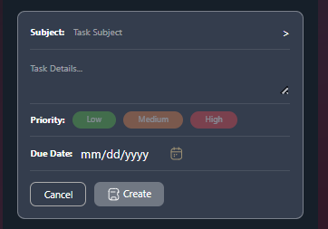
Personal Task Required Fields:
- Subject* (Required)
- Priority* (Required)
- Due Date* (Required)
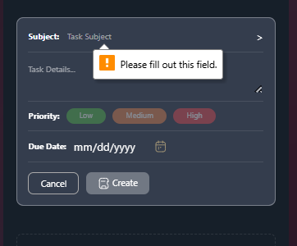
Task Cards Display:
- Task title/subject
- Due date badge (orange with fire icon if approaching)
- Status indicator
- Color-coded borders based on priority
- Action buttons (top right):
- Delete button 🗑️: Remove the task permanently
- Update button ✏️: Edit task details
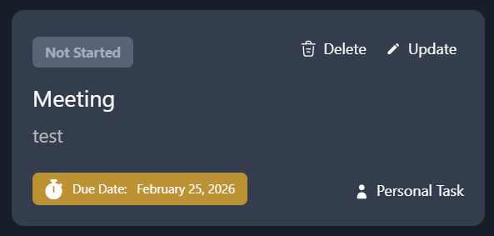
Personal Tasks vs. Subtasks:
Identifying Subtasks:
- Subtasks have a specific icon/logo to differentiate them from regular tasks
- Indented under parent task in list view
- Linked to parent task in task details
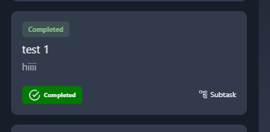
Creating Subtasks:
- From personal task, click "Add Subtask" option
- Required field: Subject only
- Due Date: Optional - if not specified, automatically inherits parent task's due date
- All other fields optional
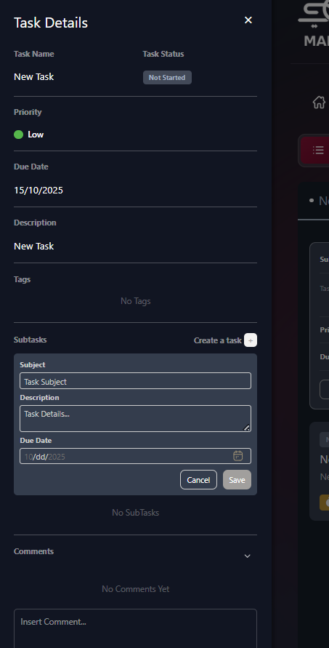
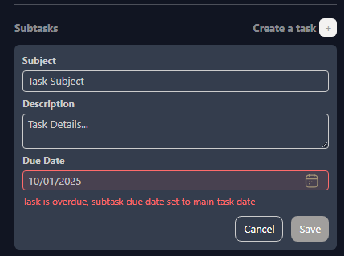
Two Ways to Complete Subtasks
Method 1: Complete Subtasks Individually
- Open the subtask
- Drag to "Completed" column
- Add completion notes
- Mark as complete
Method 2: Automatic Completion via Parent Task
- When you mark the parent task as "Completed"
- All associated subtasks automatically change to "Completed" status
- Saves time when entire project is finished
- Note: Review all subtasks before completing parent task
Calendar View
Three Calendar Formats:
      - Week View
  - Shows one week (Oct 12-18, 2025)
  - Hourly time slots (6am-6pm+)
  - Tasks displayed on specific days
  - All-day tasks shown at top
  - Navigation arrows to move between weeks
  - Today button: Jump to current date
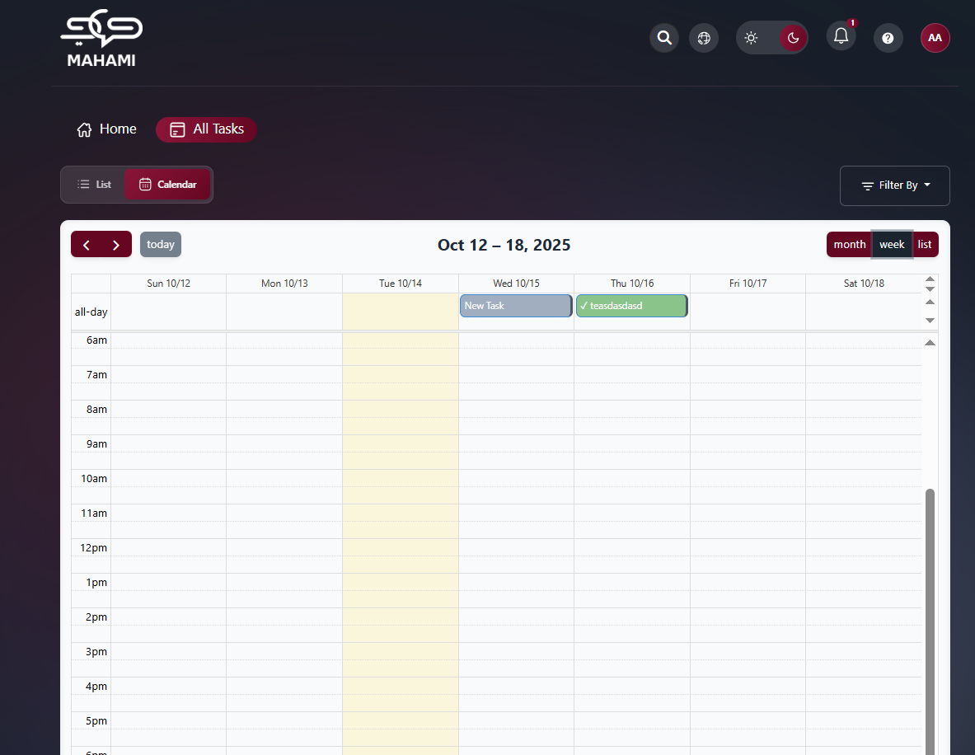
      - Month View
  - Shows full month (October 2025)
  - Tasks displayed on their due dates
  - Multiple tasks per day shown as stacked cards
  - Color-coded task cards:
- Green: Completed tasks with checkmark
- Gray: Not started tasks
  - Day numbers in corners
  - Current day highlighted (yellow background)
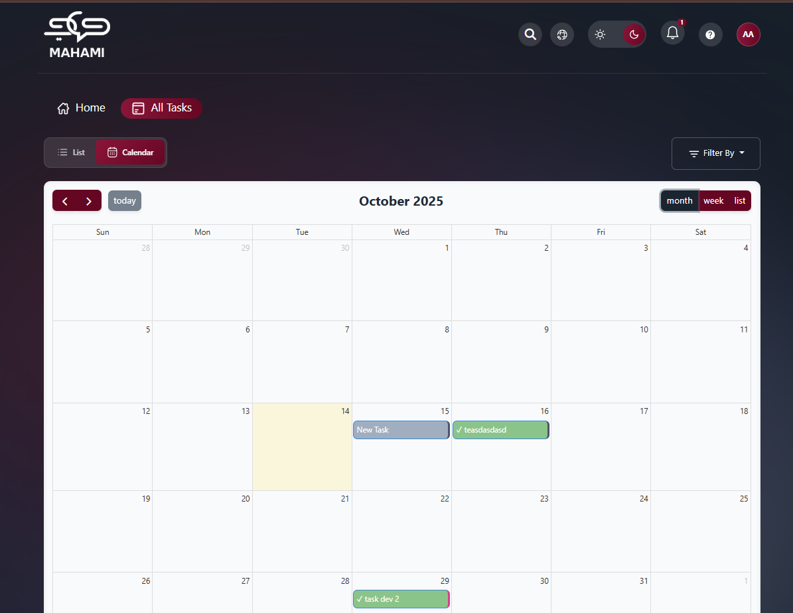
      - List View (Calendar Style)
  - Shows specific date
  - All-day section at top
  - Clean daily agenda format
  - Tasks listed with checkmarks
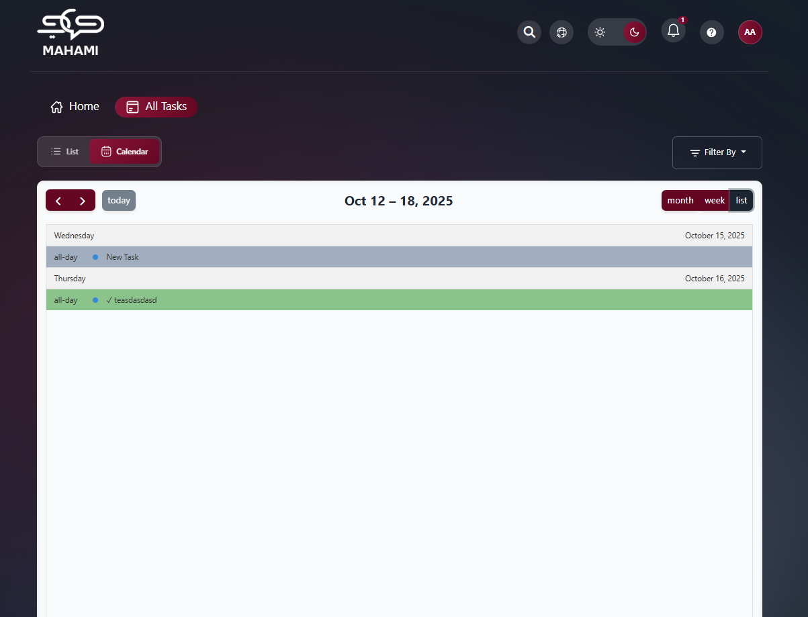
View Toggle Buttons:
- month: Monthly calendar view
- week: Weekly schedule view
- list: Daily list view
Calendar Features:
- Click on task to view details
- Tasks color-coded by status
- Checkmark indicates completed tasks
- Easy visual planning of workload

